|  |
| --- |
| C:\Users\PC\Pictures\tmvlogo.png  **Tilak Maharashtra Vidyapeeth**  **Department Of Computer Science**  **A PROJECT REPORT**  On |
| **“SHOESHOP”**  By  **SHEKH SAMIR SHEKH SALIM BAGWAN**  **[PRN: 04419003591]**  Towards The Partial Fulfilment of the  **Bachelor Of Computer Applications**  Yash InfoTech – 231 Mumbai |
| **Tilak Maharashtra Vidyapeeth, Pune**  Department Of Computer Science  **2021 - 22** |



**CERTIFICATE**

This is to certify that the project

**“SHOESHOP”**

Has been satisfactorily completed by

**SHEKH SAMIR SHEKH SALIM BAGWAN**

**[PRN: 04419003591]**

Towards The Partial Fulfilment of the

**‘Bachelor of Computer Application’**,

For the Academic Year

**2021-22 at Yash Infotech - 231, Mumbai,**

**Tilak Maharashtra Vidyapeeth – Pune**

**(Department Of Computer Science)**

**And it is approved.**

**Project Guide Examiner Head of Department**

**[T.M.V]**

|  |
| --- |
| C:\Users\PC\Pictures\tmvlogo.png  **Tilak Maharashtra Vidyapeeth**  **Department of Computer Science** |
| **ACKNOWLEDGEMENT**  With immense please we are presenting  **“SHOESHOP”**  Project report as part of the curriculum of  ‘**Bachelor of Computer Applications**  We wish to thank all the people who gave us unending support.  We express our profound thanks to our  Head Of Department **Mr. Sharad Chavan,** project guid**e Mr. Atul Vishwakarma** and project in-charge **Mrs. Tejasvi Kanade** and all those who have indirectly guided and helped us  In the preparation for this project.  **SHEKH SAMIR SHEKH SALIM BAGWAN**  **[PRN: 04419003591]** |

**Index**

|  |  |  |
| --- | --- | --- |
| **Chapter No.** | **Description** | **Page No.** |
|  |  |  |
| **Chapter 1.** | **Introduction** | **1** |
|  |  |  |
| 1.1 | Company Profile | 2 |
| 1.2 | Existing System | 5 |
| 1.3 | problem in Existing system | 7 |
| 1.4 | Need for Computerization | 12 |
|  |  |  |
| **Chapter 2.** | **Proposed System** | **16** |
|  |  |  |
| 1.2 | Proposed System | 16 |
| 2.2 | Hardware and Software Specification | 19 |
| 2.3 | Feasibility Study | 20 |
| 2.4 | Fact-Finding Techniques | 25 |
|  |  |  |
| **Chapter 3.** | **Analysis** | **37** |
|  |  |  |
| 3.1 | Nomenclature(ERD,DFD,FDD) | 37 |
| 3.2 | Functional Decomposition Diagram | 45 |
| 3.3 | Context Level Diagram | 46 |
| 3.4 | Entity Relationship Diagram | 47 |
| 3.5 | Data Flow Diagram | 48 |
|  |  |  |

|  |  |  |
| --- | --- | --- |
|  |  |  |
| **Chapter 4.** | **System Design** | **67** |
|  |  |  |
| 4.1 | Data Element Dictionary | 67 |
| 4.2 | Table Design | 71 |
| 4.3 | Program Specification | 73 |
| 4.4 | Input Screen Design | 83 |
|  |  |  |
| **Chapter 5.** | **Testing Procedure** | **96** |
|  |  |  |
| **Chapter 6.** | **Output Design** | **98** |
|  |  |  |
| **Chapter 7.** | **Implementation Procedure** |  |
|  |  |  |
| **Chapter 8.** | **User Manual** |  |
|  |  |  |
| **Chapter 9.** | **Scope For Future Enhancement** |  |
|  |  |  |
| **Chapter 10.** | **Conclusion** |  |
|  |  |  |
| **Chapter 11.** | **Bibliography** |  |
|  |  |  |

**SYNOPSIS**

**SHOESHOP**

Name: **SHEKH SAMIR SHEKH SALIM BAGWAN**

PRN: 04419003591

**Introduction**

E-Commerce, also known as electronic commerce or internet commerce, is an activity of buying and selling goods or services over the internet or open networks. So, any kind of transaction (whether money, funds, or data) is considered as E-commerce. So, E-commerce can be defined in many ways, some define E-Commerce as buying and selling goods and services over the Internet, others define E-Commerce as retail sales to consumers for which the transaction takes place on open networks. The buying and selling of products, services, and digital products through the Internet all fall under the umbrella of e-commerce.

E-commerce refers to commercial transactions of goods or services conducted over the internet.  Over the past several years, e-commerce has rapidly evolved to become a combination of online and offline retail that is vertically integrated.  You can find numerous e-commerce companies selling various types of products and services. Their avenues of doing business are typically divided into three main categories:

Some of the major players in the e-commerce industry, such as Amazon, Alibaba, and eBay, are well known by the public and own a large proportion of the market share.  These companies sell products of various brands, while other companies, such as Zalando and ASOS, also offer products of their own brands.

With an ever-increasing level of marketplace competition, there is more and more overlap of the kinds of goods and services retailers provide. For example, while still primarily a gateway for third-party sellers, Amazon is increasingly developing and marketing its own brand of products.

**Application Type:**

* Websites

**Module:**

* Client
* Admin

**Hardware Requirement:**

**Software Requirement:**

1. Android OS

**Language:**

Frontend: HTML, CSS, JavaScipt, reactJS, Bootstrap

Backend: Node.js, Express, MongoDB

**Gantt chart**

|  |  |  |
| --- | --- | --- |
| **Sr. No.** | **Task** | **Duration (Days)**  Approx. |
| 1. | Analysing Project Concept | 4-5 days |
| 2. | Information Gathering | 7 days |
| 3. | Making UI | 6 days |
| 4. | Authentication | 8 days |
| 5. | Firebase Setup | 3 days |
| 6. | Models Training | 8 days |
| 7. | Coding | 16 days |
| 8. | Analysing and Problem solving | 4 days |
| 9. | Testing | 4 days |
| 10. | Implementation | 5 days |

REAL-TIME OBJECT DETECTION

2021-22

Page - 1

**1. INTRODUCTION**

E-commerce is electronic commerce or internet commerce which involves buying and selling of goods and services via the medium of internet and any digital platform. E-commerce has predominantly impacted the modern business era, forcing every businesses to use electronic medium in their operations. All the market leading businesses, we see today, are e-commerce businesses.

eCommerce is India’s fastest growing and most exciting channel for commercial transactions.  The Indian e-commerce market is expected to grow to US$200 billion by 2026 from US$ 48.5billion as of 2018.  This growth has been triggered by increasing internet and smartphone penetration.

The e-commerce industry has a booming growth rate of 23%.In, the retail e-commerce sales was worth USD 4.28 trillion worldwide. By 2040, 95% of all purchases will be through e-commerce. E-Commerce is the next big thing in the business world.

**TYPES OF E-COMMERCE BUSINESS MODEL**

When someone is planning to start an e-commerce business, it is most probable that it will fall under one of the following categories of e-commerce business model. Every business model has its benefits and challenges and requires a different approach to business. The four general e-commerce model are;

1. **B2C (Business to Consumer)**
2. **B2B (Business to Business)**
3. **C2B (Consumer to Business)**
4. **C2C (Consumer to Business)**

REAL-TIME OBJECT DETECTION

2021-22

Page - 2

* 1. **Company Profile: -**

Globalization as well as information technology (IT) change the method of the business doing by the organizations. In almost all companies that have invested largely in the IT infrastructure for the ultimate growth of their company, the IT system is implemented and integrated. The utilization of e-commerce (EC) as a way to execute transactions related to business is increasing concern. It has been a priority for many companies. With EC, businesses will link "Just in Time production" and "Just in Time" to their trading partners, who boost their strategic abilities worldwide. EC's description is not widely agreed upon. From the communications point of view, EC may represent information, services as well products or online payments through telephone lines, computer networking, or other means from a communication point of view. EC implements technology for automating corporate transactions and workflows from a business process perspective. From a service viewpoint, EC is a way of lowering services costs while enhancing product efficiency and speeding up the delivery of services, which addresses industry, customers and management's desire. EC offers online shopping and distributing goods and information for the Internet and other online resources from an online point of view. Because of Internet and network technology's popularity and accelerated expansion, the electronic industry has become a significant field for contemporary enterprises. Large company operations are being carried out online today. People sell and purchase products and services online, and without internet infrastructure, certain purchases cannot be done [2]. This review article provides an overview of electronic commerce, mainly focused on its definition and why it is important for the modern market. It also discussed the different types of electronic commerce fields and their facilitators. Apart from the benefits offering by e-commerce, there are some disadvantages also that will be discussed in the subsequent sections. The last sections will discuss the trend and future of electronic commerce in India.

E-commerce is referred to as electronic commerce. It means the electronic media and the internet for dealing with goods and services. E-Commerce entails a company accessing the internet as well as IT, such as the electronic data interchange (EDI). E-commerce concerns an internet vendor's website, trading goods or services to the user directly from the platform.

REAL-TIME OBJECT DETECTION

2021-22

Page - 3

The gateway uses a wireless purchase cart or a purchase basket to pay by credit card, debit card or Electronic fund transfer (EFT). A further description is as follows: Electronic communications and digital information processes in business transactions are used to create, modify and redefine value generation relations between, and between, organizations and individuals.With the increasing spread of ICTs, specifically the Internet, the global corporate world pushes rapidly into ecommerce (Business-to-Business). As the Internet enables consumers to enter the global economy, they can compare prices across areas, find out how they vary by request, and become aware of substitution. The buyers obtain a distinct advantage. Thanks to market openness, consumers can conveniently compare e-commerce offerings from different websites. The rivals would immediately be one click away from the customer if the company is electronic. If consumers aren't comfortable with certain e-goods, content's pricing or services, they can adjust even more quickly than in traditional terms. They don't need a physical store from the point of view of the vendors

**E-Commerce Facilitators**

1. Internet: E-commerce has grown through huge penetration of the internet. The Internet and intelligent mobile telephones have literally been part of every life. Internet no longer constitutes an intelligence source, however, it is an efficient means in which horsemen, and carpenters, physicians etc. can buy, read, communicate and even receive service. The supply chain is slender and intelligent, as digital networks can quickly link to customers, which greatly minimizes pollution and benefits green businesses. In the last 20 years, the ICT revolution has powered the economy unprecedentedly.
2. The number of network users exploded with the advent of the World Wide Web and later the expansion of multimedia content. The internet has in turn evolved even quicker than any other previous medium. The United Nations International Telecommunication Union (ITU) recently forecast 3.2 billion users online in 2015.

REAL-TIME OBJECT DETECTION

2021-22

Page - 4

3. Payment Gateway: The payment transfer, which allows e-commerce, online shops, bricks, and clicks and traditional brick and mortar payments via credit card, is an ecommerce application service provider service. The main variables in internet transactions are payment routes that include credit cards, debit cards, online banking purchases, and transfers of electronic funds. There is a need for payment gates for sustainable future e-Commerce, and the environment shifts from cash into digital currency.

4. Analytics: Analytics is the empirical way of transforming data into decision-making intelligence. Analytics assists organizations in collecting, arranging, reviewing and commenting on their clients. The vast rise in data volume has caused organizations to rely on research to know the customer's behavior. Retailers must have real-time access to knowledge to compute returns on internet investments and a channel blend. Basic analytics are available for e-commerce players; for customer insight, average order volume, basket size measuring, conversion ratios are required and a deeper analytical approach is needed.

5. Social Media: To advertise their goods, businesses constantly use social media. Social media involves blogs and computer applications that allow the use of the computer or cell phone for connection and exchanging the information through the internet. Social networking is more critical in the creation of products and reminds clients of different deals. The input on the product or the service is also useful. It provides a brand-building tool for creating a trustworthy group of consumers, publications, word of mouth and so on.

6. Autonomous Vehicles: Autonomous cars are belongs to the motor vehicles category that can work without direct intervention from a human operator using artificial intelligence, sensors and the global system of positioning. The age of the private car is quickly approaching. Autonomous consumers will have much time to browse the internet, read emails, purchase new items and view commercials nearby. Very vast digital media expertise is obtained for autonomous vehicles. These shopping and search trends can be traced to assist businesses in tailoring their marketing strategy to avoid this new industry. Big data are now much wider in nature but in the coming years will be so adapted and predictive that nothing can be manually modified again.

**E-Commerce Business Types**

REAL-TIME OBJECT DETECTION

2021-22

Page - 4

1. Business-to-Business (B2B): Electronic commerce B2B includes all electronic products or services transfers between firms. In general producers and traditional industrial wholesale companies use this approach for electronic trading.

2. Business-to-Consumer (B2C): Company and final client electronic company partnerships E-commerce business to consumer. It is the ecommerce shopping section, where conventional retail business typically takes place. These partnership styles can be simpler, more complex and intermittent and can be discontinued. This business type has expanded considerably because of the advent of the Internet with a number of online shops and centers that offer customers' products of any kind such as computers, electronics, books, accessories, cars, food, financial materials and digital publications. In contrast to retail sales in conventional trade, the buyer typically has more knowledge about insightful content available and it is generally accepted that you can buy cheaper, without jeopardizing a similarly individual customer experience as well as promising easy processing and distribution.

3. Consumer-to-consumer (C2C): Type C2C electronic e-commerce encompasses all trade in goods or services electronically between customers. Typically this exchange is done by a third party that offers an online transaction forum.

4. Consumer-to-business (C2B): In C2B is reversed the usual context of exchange in goods. This method of e-commerce is widely used in crowdsourcing-based companies. For companies that aim precisely at some types of services or items, individuals also sell their services or products. These events include locations at which artists ask for several suggestions for a logo and only one is successfully selected and purchased. Another popular medium in this business segment is the markets which sell photos, photos, media and design elements free of royalty.

5. Business-to-administration (B2A): This portion comprises all internet transactions between companies and the government. This covers a wide variety of diverse programs, notably in areas such as taxation, social care, healthcare, legal documentation and records, etc. These modes of services have been significantly extended in recent years by spending in egovernment.

REAL-TIME OBJECT DETECTION

2021-22

Page - 4

6. Consumer-to-administration (C2A): The C2A model includes all electronic purchases between governments and individuals. Application highlights include: • Education – disseminating information, distance learning, etc. • Social Security – via information distribution, making payments, etc. • Taxes – filing tax returns, payments, etc. • Health – appointments, information about illnesses, payment of health services, etc

REAL-TIME OBJECT DETECTION

2021-22

Page - 5

* 1. **Existing System: -**

Ecommerce website can be used to manage your online store and handle tasks such as adding and removing products, tracking inventory, calculating taxes and other work required to fulfill orders placed on the website. The software is easy to use but also offers complex features. You can easily integrate eCommerce software with your existing accounting, ERP and other systems, improve marketing by connecting to social channels such as Facebook, Pinterest, and Twitter, and automate data sharing. Key benefits of eCommerce software include customer and order management, product management, automation of taxes and shipping, simplified marketing, and enhanced overall user experience. This article lists the best eCommerce software solutions in the market and provides detailed reviews of the 10 most popular products. Salesforce Commerce Cloud has managed to climb the ranks all the way to the top spot, making it an eCommerce tool worth checking out. We are sure you can find a suitable app among them for your online selling needs.

Our team of experts reviewed the leading eCommerce solutions and Salesforce Commerce Cloud came in the first place. This solution offers robust AI-powered features and is offered in customizable and scalable plans.

Coming from the popular CRM suite, Salesforce, this solution combines the key features inherent to an eCommerce platform with functionalities that boost customer engagement and experience. It supports storefront personalization, multiple carts, multi-account ordering, personalized coupons, and split shipments. Moreover, its quick order and reorder templates are designed to streamline the buying process further.

E-commerce capabilities are provided by information technology-based information systems. By an e-commerce system we mean an information system that processes data and provides information to support the operations and management of an organization’s electronic commerce activities.

Operations include advertising, selling, order entry, order fulfillment, billing, customer support, and related activities. Management involves decision-making tasks and may include customer targeting, product promotion management, sales analysis, and credit management

REAL-TIME OBJECT DETECTION

2021-22

Page - 6

Drawbacks of existing system:

* **Some products are difficult to buy online**

If you think that you can buy everything online then it is your misconception. There are products for instance eatables like ice cream, spectacles, and metals like gold and silver that you do not want to buy online even if you have the option of doing so.

* **Late delivery**

Late delivery is one of the common disadvantages of e-commerce platforms. While ordering a product the customer is assured that it will reach him in maximum seven days or a particular time period.

* **Shipping problems**

E-commerce stores run successfully because it can ship its products from anywhere to everywhere with ease.

* **Severe competition**

Healthy competition is considered a plus in the business sector but what happens when there are unimaginable portals for a single product.

* **No possibility of tried a**n**d tested product**

One of the major disadvantages of e-commerce portal is that a customer is unable to try and test the product for his own satisfaction.

**1.3) Problems in Existing System:-**

REAL-TIME OBJECT DETECTION

2021-22

Page - 7

The e-commerce industry has grown exponentially, with total e-commerce sales expected to reach $1.065 trillion by 2023. As an e-commerce business owner, you have unique challenges compared to brick-and-mortar shop owners. E-commerce businesses have unique rules and regulations to follow, and cybersecurity is a top priority to ensure all data stored online is protected.

* **Competition**

Competition comes in many forms for small businesses, especially in the e-commerce space. You have to keep up with competitive pricing, products and services – all competing for your target customer. As a small business, you can overcome price competition by having a very clear company value proposition that consumers can’t get elsewhere,” said Calloway Cook, founder of Illuminate Labs. The e-commerce space has become so saturated that standing out from other e-commerce businesses is challenging, through no fault of your own

.

* **Order fulfilment**

Not everything has to fall on the small business owner’s back. You could be inundated with more orders than you are prepared to handle on your own. In this case, outsourcing order fulfillment and e-commerce shipping can ease your workload and streamline the customer experience.

* **Customer experience**

As a primarily e-commerce business or a business that conducts some selling online, you might find it a challenge to offer your customers the same experience level they would get in a brick-and-mortar store.“One of the most overlooked areas of the customer experience in moving to e-commerce is pricing and customer segmentation,” said George Dunham,

CEO of epaCUBE. “Customer experience is especially important when launching an e-commerce initiative, because customers expect to be treated as well or better online as they are face to face.”Dunham said that companies struggle to meet these new demands because doing so requires precise handling of pricing, analytics and customer segmentation. Successful experiences in the e-commerce space require the same, if not greater, clarity in product offerings, pricing, loyalty programs and more, as is required in a face-to-face buying process. “In a world where everything is happening online, your customers expect more, and they also know more about your products, prices and competition,” Dunham said. “They expect to be treated the same way online as offline, so if they can get a certain price in person but can’t get that price online, they get frustrated and purchase somewhere else.”

* **Visibility**

How are you supposed to get quality traffic to your site and turn visitors into customers if people can’t find your site? It’s a significant issue for e-commerce businesses and one that could make or break a business.

“If the company doesn’t show up on the first page of Google’s search results for relevant keywords, then it’s unlikely that prospective customers will find them,” said Michael Anderson, marketing and SEO specialist at GeoJango Maps. “The best way to overcome this challenge is to invest in SEO. E-commerce companies should conduct keyword research, implement on-page SEO best practices, and work on building high-authority links to their website.”

REAL-TIME OBJECT DETECTION

2021-22

Page - 8

REAL-TIME OBJECT DETECTION

2021-22

Page - 9

**1.4) Needs For Computerization: -**

It's still possible to operate a business without a computer, but it would have to be a very small business and you'd definitely be doing things the hard way. Since you've likely got computers in your business anyway, it makes sense to maximize the value you get from them. One way to do that is by computerizing your inventory system. You can use the computer just to speed record keeping or go to a full-blown, real-time inventory system, depending on your needs, but either way, you'll benefit from having it computerized.

Computerized inventory systems make shipping and receiving orders simpler as well, and leave less room for error. You can simply scan the product into inventory as it's received, and it will show in your on-hand inventory. In much the same way, when you send out an order to your customers, you can scan each item out of inventory.

In retail, your cashiers do the same thing as they swipe or scan each item sold. You'll still need to train your staff to double-check the contents of each box against the order or invoice, but you're still eliminating one or more data entry steps in which errors can occur.If you use a periodic inventory system, your book inventory count will usually be outdated by the time your accountant finishes updating the data. This means you'll need to always carry at least a small amount of extra inventory to cover your projected sales, or your projected production if you're a restaurant or manufacturer. That ties up money and storage space you'd otherwise have at your disposal.

* Ecommerce is the buying and selling of goods and services over the Internet.
* It is conducted over computers, tablets, smartphones, and other smart devices.
* Almost anything can be purchased through ecommerce today.
* It can be a substitute for brick-and-mortar stores, though some businesses choose to maintain both.
* Ecommerce operates in four market segments, including business-to-business, business-to-consumer, consumer-to-consumer, and consumer-to-business.

**Following Is the Importance of Computerization: -**

REAL-TIME OBJECT DETECTION

2021-22

Page - 10

1. **Time and Cost Savings: -**

Using a computerized accounting system saves companies time and money. The use of computers makes inputting accounting information simple. Business transactions are entered into the system and the system posts transactions accordingly.

1. **Organization: -**

A computerized accounting system help business stay organized. When information is entered into the system. it makes finding the information easy. Employees can see any financial information whenever it is needed.

1. **Storage: -**

Storing information is vital to a business. In a computerized system, data can be stored quickly. After the information is entered into the system the information is stored indefinitely. Companies perform backups on the system regularly to avoid losing any information.

1. **Distribution: -**

Computerized accounting systems allow companies to distribute financial information easily. Financial statements are printed directly from the system and are distributed internally and externally to those needing the information.

1. **Management Reports: -**

Data within the computerized accounting system is accurate and up-to-date. Management can request an online report in real-time and that makes management decisions more reliable and timelier.

REAL-TIME OBJECT DETECTION

2021-22

Page - 11

1. **Regulatory Compliance: -** Reports are required on a regular basis from various government agencies. A computer system can organize its data and reports to comply with this statutory requirement savings time.
2. **Speed and Efficiency**

A computerized system offers greater speed than a paper system. Rather than have to sort through piles of documents to find information, the user can often find what's needed with just a few keystrokes or mouse clicks. Users can also create customized subfolders within documents that provide more efficient document management. Greater speed and efficiency result in greater productivity and less wasted time, which can help to improve the organization's bottom line.

1. **Legibility and Accuracy**

Over time, paper documents can become smudged, faded or damaged, making the information hard to decipher. With handwritten documents, poor penmanship can also render the information illegible, and when an individual who added an illegibly written entry to a file leaves the organization, nobody may be able to "translate" the information. Misfiled documents can be difficult to find when they are needed the most. A computerized system can eliminate these issues, resulting in a more accurate and organized method of document management over the long term

**2. PROPOSED SYSTEM**

REAL-TIME OBJECT DETECTION

2021-22

Page - 12

**2.1) Proposed System:-**

The ShoeShop has many advantages, compare to traditional store as one can compare the cost of a product with other e-commerce websites While we can make use of the current technology to overcome the problem with the existing system. And in this way. While before sending a product the e-commerce company will check the product that it is same or not with the requested order

**Shoe-Ecom Module:**

* **Registration**  
  In order to use the system the users will need to register in the system, and for registration, they need to provide various information related to them such as name, address, etc.
* **Search bar**  
  This provides users with an option through which they can search the product they want to purchase.
* **Cart**  
  After selecting a product if the user wants to purchase it, later they can save the product in the cart.
* **Check out**  
  Through this module, the user can place their order and can choose preferred method for payment.
* **Purchase history**  
  This will show the purchase done by the user in the past.
* **Admin Panel**  
  From this admin can CRUD operation,Check details of orders
* It saves users time.
* Simple UI
* The system is built upon a smart technology
* This system is made more user friendly.

REAL-TIME OBJECT DETECTION

2021-22

Page - 13

**2.2) Hardware and Software:-**

REAL-TIME OBJECT DETECTION

2021-22

Page - 14

* **Hardware Specifications:**
* Processor : Intel Pentium G4560 or higher
* RAM : 8GB
* Hard Disk : 500GB
* **Software Specification**
* Operating System : Windows
* Browsers : Chrome & Brave
* Database : MongoDB atlas
* Server : Node.JS, Express
* Programming language : JavaScript
* Application : Website

**2.3) Feasibility Study:-**

REAL-TIME OBJECT DETECTION

2021-22

Page - 15

A feasibility study is an assessment of the practicality of a proposed project or system. A feasibility study aims to objectively and rationally uncover the strengths and weaknesses of an existing business or proposed venture, opportunities and threats present in the natural environment, the resources required to carry through, and ultimately the prospects for success. In its simplest terms, the two criteria to judge feasibility are required and value to be attained.

A well-designed feasibility study should provide a historical background of the business or project, a description of the product or services, accounting statements, details of the operations and management, marketing research and policies, financial data, legal requirements and tax obligations. Generally, feasibility studies precede technical development and project implementation. A feasibility study evaluates the project's potential for success; therefore, perceived objectivity is an important factor in the credibility of the study for potential investors and lending institutions. It must therefore be conducted with an objective, unbiased approach to provide information upon which decisions can be based.

The feasibility study is a high-level capsule version of the entire process. A feasibility study includes the estimate of a level of exercise required for a project and who can provide it. Quantitative and qualitative assessments of other essential resources, identification of critical points, a general timetable and a general cost estimate. Whether a project is viable or not i.e., whether it can generate an equal or a higher rate of return during its lifetime thus requires a tough investigation of the investment per se as well as the level of current expenditure. The preliminary design is a simple description of the conceived idea with an indication of the main factors to be considered in the study.

The following are some type’s feasibilities which are considered for the project in order to ensure that the project is variable and it does not have any major obstructions. A feasibility study encompasses the following things:

REAL-TIME OBJECT DETECTION

2021-22

Page - 16

* **Technical Feasibility: -**

A technical feasibility study assesses the details of how you intend to deliver a product or service to customers. Think materials, labour, transportation, where your business will be located, and the technology that will be necessary to bring all this together

* **Economic Feasibility: -**

Economic feasibility is the cost and logistical outlook for a business project or endeavour.

* **Operational Feasibility: -**

Operational feasibility is the measure of how well a proposed system solves the problems and takes advantage of the opportunities identified during scope definition and how it satisfies the requirements identified in the requirements analysis phase of system development.

* **Legal Feasibility: -**

In legal feasibility, the assessment investigates whether any aspect of the proposed project conflicts with legal requirements like zoning laws, data protection acts or social media laws.

* **Scheduling Feasibility: -**

The scheduling feasibility is most important for project success. After all, a project will fail if not completed on time. In this, the organisation estimates how much time the project will take to complete.

REAL-TIME OBJECT DETECTION

2021-22

Page - 17

Here I’m explaining three different cases where my project can be used and will create a great impact. It will provide a perfect solution in all cases where Ecommerce can be used

* Business to Consumer
* Business to Business
* Direct to Consumer
* **Let’s Get Into Details Of Each Case: -**

1. **Business to Consumer (B2C):**

B2C e-commerce is the most popular e-commerce model. Business to consumer means that the sale is taking place between a business and a consumer, like when you buy a rug from an online retailer.

1. **Business to Business (B2B):**

B2B e-commerce refers to a business selling a good or service to another business, like a manufacturer and , or a wholesaler and a retailer. Business to business e-commerce isn’t consumer-facing, and usually involves products like raw materials, software, or products that are combined. Manufacturers also sell directly to retailers via B2B ecommerce.

1. **Direct to Consumer (D2C):**

Direct to consumer e-commerce is the newest model of ecommerce, and are continually changing. D2C means that a brand is selling directly to their end customer without going through a retailer, distributor, or wholesaler. Subscriptions are a popular D2C item, and social selling via platforms like InstaGram, Pinterest, TikTok, Facebook, SnapChat, etc. are popular platforms for direct to consumer sales.

REAL-TIME OBJECT DETECTION

2021-22

Page - 19

**2.4) Fact-Finding Techniques: -**

Fact-finding is the process of collection of data and information based on techniques which contain a sampling of existing documents, research, observation, questionnaires, interviews, prototyping and joint requirements planning. System analyst uses suitable fact-finding techniques to develop and implement the current existing system. Collecting required facts are very important to apply tools to the system development life cycle (S.D.L.C) because tools cannot be used efficiently and effectively without proper extracting from facts. Fact-finding techniques are used in the early stage of (S.D.L.C) including the system analysis phase, design and post-implementation review. Facts included in any information system can be tested based on three steps: data- facts used to create useful information, process - functions to perform the objectives and interface- designs to interact with users.

* + There Are Five Widely Used Fact-Finding Techniques: -
* Examining documentation
* Interviewing
* Observing the enterprise in action
* Research
* Questionnaires

REAL-TIME OBJECT DETECTION

2021-22

Page - 20

* **Let Us Discuss In Brief Each Of Them: -**
* **Examining Documentation: -**

It can be helpful when you try to gain some insight as to how the requirement for a database arose. You may also find that documentation can help to acquire information on the part of the enterprise associated with the problem. If the problem relates to the current system, there should have to be documents associated with that system. By examining documents, forms, reports, and files associated with the current system, you can quickly gain some thoughtful concepts about the system.

* **Interviewing: -**

It is the most frequently used, and usually the most useful, fact-finding procedure used. We can interview to collect information from person face-to-face. There can be several objectives for using interviewing, such as finding out facts, verifying those facts, clarifying these released facts, generating enthusiasm, getting the end-user involved, identifying requirements, and gathering ideas and opinions.

* **Observing The Enterprise In Action: -**

Observation is one of the most successful fact-finding techniques carried out for understanding a system. Using this technique, it is achievable to either participate in or observe a person perform activities to learn about the system.

* **Research: -**

A useful fact-finding technique is to research the application or the problem that you are dealing with and want to put within a database. Computer trade journals, reference books, and the Internet are good sources of information that can make available the vast quantity of information on how others have solved similar problems/issues plus whether or not any software packages exist to resolve or even partially solve your current problem.

REAL-TIME OBJECT DETECTION

2021-22

Page - 21

Research contains important and redefining problems, formulates optional solutions by collecting, organizing and evaluating data; building deductions and receiving conclusions; and at last suspiciously testing the conclusions to decide whether they fit the formulating research.

**Of Type Research: -**

Descriptive research includes surveys and fact-finding enquiries of diverse kinds. The main point of this process is that the researcher has no organisation over the variables; he can only give a description about what has happened or what is happening.

**Data Sources: -**

There are two types of data. The Source of primary data for the at hand study is composed through a questionnaire and answered by consumers. The secondary data is collected from journals, books and online websites.

**Primary Data: -**

The data that is composed first-hand by someone, particularly for the use of facilitating the study is known as primary data. So, in this research, the data is collected from respondents through a questionnaire.

**Secondary Data:** -

For the company information, I used secondary data like journal articles, the website of the company etc. The method used by me is the survey method as the research done is descriptive

REAL-TIME OBJECT DETECTION

2021-22

Page - 22

* + **Pie Chart On Public Responses:-**

**The results show that websites still dominate the world of eCommerce. Specifically, 69% of respondents said they shop online primarily via websites (30% primarily via PC and 39% primarily via smartphone or tablet). Meanwhile, only 27% of respondents said they shop online primarily via mobile shopping apps**.

REAL-TIME OBJECT DETECTION

2021-22

Page - 23

**There are many ecommerce website but most percentage held by big company like amazon,**

**Flipkart and snapdeal etc its hold almost 70% of market, other small store also run their own ecommerce website to sell their products, and other 8% is startUp**

REAL-TIME OBJECT DETECTION

2021-22

Page - 24

**With a majority of vote of 46% most user prefer using Amazon**

REAL-TIME OBJECT DETECTION

2021-22

Page - 25

**E-commerce players expect cash on delivery (COD) to come down, and mobile payments, coupled with Aadhaar, can be a game changer.**

REAL-TIME OBJECT DETECTION

2021-22

Page - 26

**E-commerce is one of the most well-established and well-funded categories within tech. Between 2012 and 2020, private e-commerce companies raised.**

REAL-TIME OBJECT DETECTION

2021-22

Page - 27

**3. ANALYSIS**

**3.1) Nomenclature (ERD, DFD, FDD Symbols):**

* **Nomenclature: -**

One of the essential tasks for (I.T) projects leader or architect is to have an application diagram created. It could be either application flow, infrastructure diagram or software design It is a process of converting a relation to a standard form. The process is used to handle the problems that can arise due to data redundancy i.e. repetition of data in the database, maintaining data integrity as well as handling problems that can arise due to insertion, updating, and deletion anomalies. Decomposing is the process of spitting relations into multiple relations to eliminate anomalies and maintain anomalies and maintain data integrity. To do this we use normal forms or rules for structuring relations.

* **Insertion Anomaly: -**

Inability to add data to the database due to the absence of other data.

* **Deletion Anomaly: -**

Unintended loss of data due to deletion of other data.

* **Update Anomaly: -**

Data inconsistency resulting from data redundancy and partial update.

* **Normal Forms: -**

These are the rules for structuring relations that eliminate anomalies.

REAL-TIME OBJECT DETECTION

2021-22

Page - 28

* **Entity Relationship Diagram (Symbols): -**

(E.R-modelling) is a data modelling method used in software engineering to produce a conceptual data model of an information system? Diagrams created using this (E.R-modelling) method are called entity-relationship diagrams or (E.R) diagrams or (E.R.D). By defining the entities, and their attributes, and showing the relationships between them, an (E.R) diagram illustrates the logical structure of databases. (E.R) diagrams are used to sketch out the design of a database. When documenting a system or process, looking at the system in multiple ways increases the understanding of that system. (E.R) diagrams are commonly used in conjunction with a data flow diagram to display the contents of a data store. They help us to visualize how data is connected in a general way, and are particularly useful for constructing a relational database. Entity-relationship diagrams don't show single entities or single instances of relations. Rather, they show entity sets and relationship sets.

An entity-relationship model describes interrelated things of interest in a specific domain of knowledge. A basic (E.R) model is composed of entity types and specifies relationships that can exist between entities. In software engineering, an (E.R) model is commonly formed to represent things a business needs to remember in order to perform business processes. Consequently, the (E.R) model becomes an abstract data model, which defines a data or information structure which can be implemented in a database, typically a relational database. An (E.R) model is usually the result of systematic analysis to define and describe what is important to processes in an area of a business. It does not define the business processes; it only presents a business data schema in graphical form. It is usually drawn in a graphical form as boxes that are connected by lines which express the associations and dependencies between entities. An (E.R) model can also be expressed in a verbal form.

REAL-TIME OBJECT DETECTION

2021-22

Page - 29

|  |  |
| --- | --- |
|  | **Entity**  An entity is an object or concept about which you want to store information. An entity can be a place, person, object, event or concept. Entities are represented by rectangles. |
|  | **Relationship**  The relationship is nothing but an association among two or more entities. Relationships are also called actions, which are represented by diamond shapes, and show how two entities share information in the database. |
|  | **Attribute**  An attribute is a single-valued property of either an entity-type or a relationship type. Attributes are represented by ovals. |

REAL-TIME OBJECT DETECTION

2021-22

Page - 30

* **Data Flow Diagram (Symbols): -**

The data flow diagram is a graphical representation of the flow of data in an information system. It is capable of depicting incoming data flow, outgoing data flow and stored data. The (D.F.D) does not mention anything about how data flows through the system. A data flow diagram shows the way information flows through a process or system.

It includes data inputs and outputs, data stores, and the various sub-processes the data moves through. (D.F. D’s) are built using standardized symbols and notation to describe various entities and their relationships.

The data flow diagram is a part of the structured – analysis modelling tool. When using (U.M.L), the activity diagram typically takes over the role of the data flow diagram. A special form of data flow plan is a site–oriented data flow plan.

The data flow diagrams can be regarded as inverted Petri nets because places in such networks correspond to the semantics of data memories. Analogously, the semantics of transitions from Petri nets and data flows and functions from dataflow diagrams should be considered equivalent.

The (D.F.D) must be consistent with other models of the system – (E.R.D, S.T.D, Data Dictionary, and Process Specification) models. Each process must have its name, inputs and outputs. Each flow should have its name. Each data store must have input and output flow. Input and output flows do not have to be displayed in one (D.F.D) - but they must exist in another (D.F.D) describing the same system. An exception is a warehouse standing outside the system with which the system communicates.

REAL-TIME OBJECT DETECTION

2021-22

Page - 31

|  |  |
| --- | --- |
|  | **Source Of Sink (External Entity)**  A source of system inputs or a sink of system inputs. |
|  | **Process**  Performs some transformation of input data to yield output data |
|  | **Data Flow**  It is used to connect processes to each other to sources or sinks; the arrow head indicates direction of data flow. |
|  | **Data Store**  A repository of data |

REAL-TIME OBJECT DETECTION

2021-22

Page - 32

* **Functional Decomposition Diagram (Symbols): -**

Functional decomposition corresponds to the various functional relationships as to how the original complex business function was developed. It mainly focuses on how the overall functionality is developed and its interaction between various components. Large or complex functionalities are more easily understood when broken down into pieces using functional decomposition.

Functional decomposition is mostly used during the project analysis phase in order to produce functional decomposition diagrams as part of the functional requirements document. The functional decomposition is done after meeting with business analysts and subject matter experts. Decompose the first level components with their functions and continue to decompose to lower levels until a sufficient level of detail is achieved perform an end-to-end walkthrough of the business operation and check each function to confirm that it is correct.

The purpose of the functional decomposition diagram is used to show on a single page the capabilities of an organization that are relevant to the consideration of an architecture. By examining the capabilities of an organization from a functional perspective, it is possible to quickly develop models of what the organization does without being dragged into an extended debate on how the organization does it. Once a basic functional decomposition diagram has been developed, it becomes possible to layer heat maps on top of this diagram to show scope and decisions. For example, the capabilities to be implemented during the different phases of a change program.

The functional decomposition diagram has its origin in mathematics, where it refers to the process of analysing the links and relationships between all the components that create a functional relationship so that the original function may be recomposed. Functional decomposition has its origin in mathematics, where it refers to the process of analysing the links and relationships between all the components that create a functional relationship so that the original function may be recomposed.

REAL-TIME OBJECT DETECTION

2021-22

Page - 33

Practically, functional decomposition is used by engineers to describe the steps taken in the act of breaking down the function of a device, process, or system into its basic components. As a result of the analysis, a functional decomposition diagram will detail the functions – tasks and sub-tasks and how they work together. The diagram may also address any problems, as well as suggest solutions to those problems.

Functional decomposition is especially important in programming. Once a diagram has been created, coding may begin as the programmer may then work on the most basic components first and then build out an application. As such, functional decomposition helps focus and simplify the programming process. One drawback, however, is that functional decomposition can be especially labour - intensive and time-consuming.

REAL-TIME OBJECT DETECTION

2021-22

Page - 34

**3.2) Functional Decomposition Diagram:**

* **Functional Decomposition Diagram For ShoeShop: -**

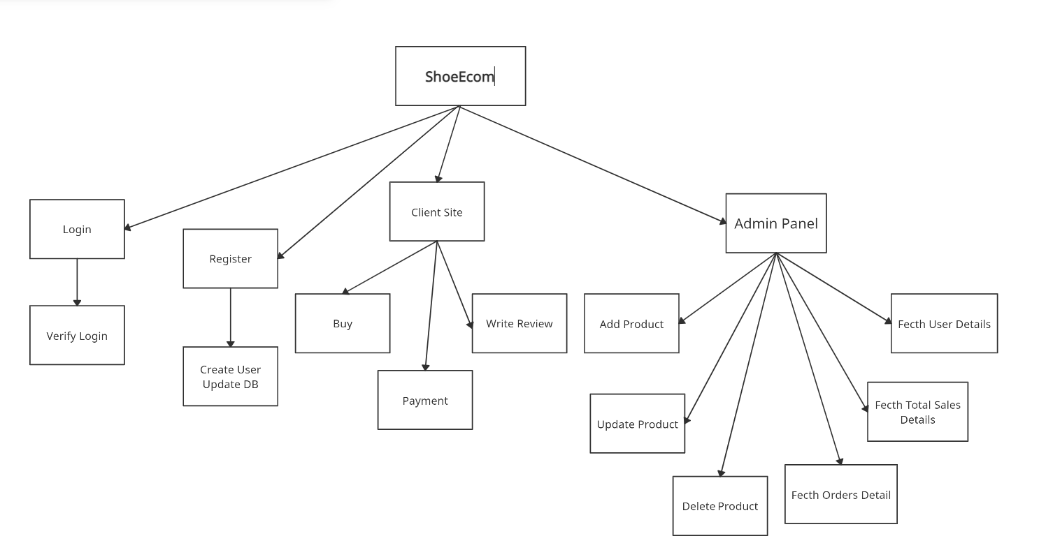

REAL-TIME OBJECT DETECTION

2021-22

Page - 35

**3.3) Context Level Diagram:**

* **Context Level Diagram ShoeShop :**

**Admin**

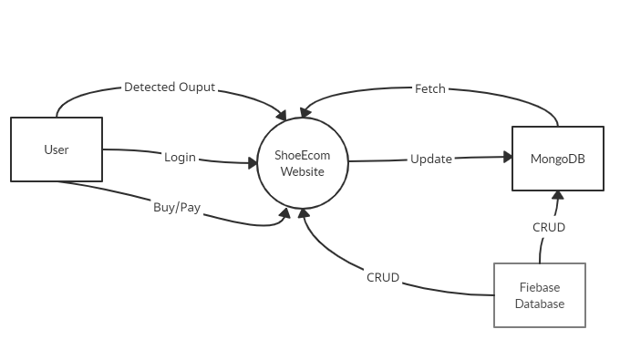

REAL-TIME OBJECT DETECTION

2021-22

Page - 36

**3.4) Entity Relationship Diagram:**

* **Entity Relationship Diagram For ShoeShop: -**

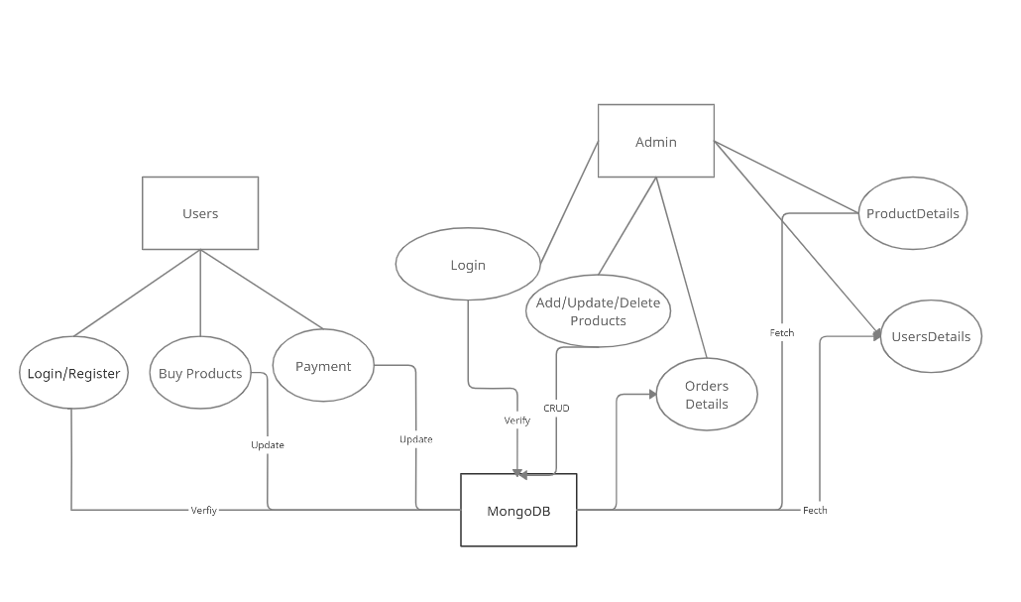

REAL-TIME OBJECT DETECTION

2021-22

Page - 37

**3.5) Data Flow Diagram:**

* **Data Flow Diagram For ShoeShop[User Registration] {First Level}:**

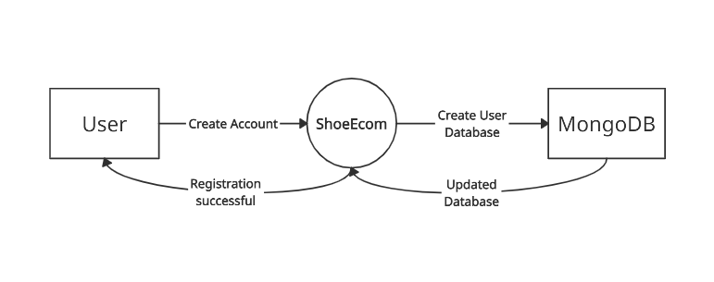

* **Data Flow Diagram For Real-Time Object Detection [User Login] {First Level}: -**

REAL-TIME OBJECT DETECTION

2021-22

Page - 38

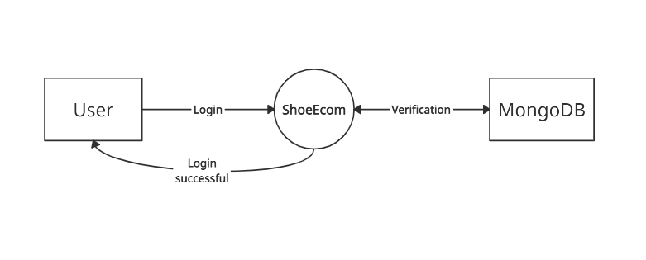

REAL-TIME OBJECT DETECTION

2021-22

Page - 39

* **Data Flow Diagram For ShoeShop Admin Panel {First Level}: -**

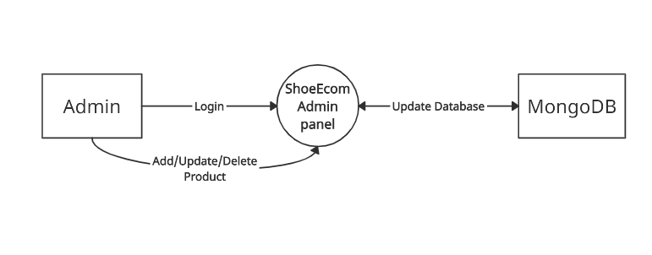

REAL-TIME OBJECT DETECTION

2021-22

Page - 40

* **Unified Modelling Language (U.M.L) Diagrams: -**
* **Symbols:**
* **Use Case Diagrams:**

A use case diagram at its simplest is a representation of a user's interaction with the system that shows the relationship between the user and the different use cases in which the user is involved. A use case diagram is a dynamic or behaviour diagram in (U.M.L). A use case diagrams model the functionality of a system using actors and use cases. Use cases are a set of actions, services, and functions that the system needs to perform. The "actors" are people or entities operating under defined roles within the system. While a use case itself might drill into a lot of detail about every possibility, a use case diagram can help provide a higher-level view of the system. It has been said before that the use case diagrams are the blueprints for your system. They provide a simplified and graphical representation of what the system must actually do. The purpose of the use case diagrams is simply to provide a high-level view of the system and convey the requirements in lay people's terms for the stakeholders. Additional diagrams and documentation can be used to provide a complete functional and technical view of the system.

REAL-TIME OBJECT DETECTION

2021-22

Page - 41

|  |  |
| --- | --- |
|  | **Actors**  The actors are the users of a system. An actor can be a person, an organisation, or an outside system that interacts with your application or system. They must be external objects that produce or consume data. The actors are stick figures that represent the people actually employing the use cases. |
|  | **System**  A system is a specific sequence of actions and interactions between actors and the system. A system may also be referred to as a scenario. |
|  | **Use Case**  A use case is a specification of the set of actions performed by a system which yields the observable result that is typical of value for one or more actors or other stakeholders of the system |
|  | **Association**  An association describes a set of tuples whose value refers to typed instances. An instance of an association is called a link. An association specifies a semantic relationship that can occur between typed instances. |

REAL-TIME OBJECT DETECTION

2021-22

Page - 42

|  |  |
| --- | --- |
| **<<include>>** | **Include**  An include relationships specifies how the behaviour for the inclusion use case is inserted into the behaviour defined for the base use case. An include relationship defines that a use case contains the behaviour defined in another use case. |
| **<<Extend>>** | **Extend**  An extend relationship specifies how the behaviour of the extension use case can be inserted into the defined for the base use case. This relationship specifies that the behaviour of a use case may be extended by the behaviour of another use case. The extension takes place at one or more specific extension points defined in the extended use case. |
|  | **Dependency**  A dependency is a relationship that signifies that a single or a set of model elements requires other model elements for their specification or implementation |

REAL-TIME OBJECT DETECTION

2021-22

Page - 43

|  |  |
| --- | --- |
|  | **Generalization**  A generalization relationship is used to represent inheritance relationship between model elements of same type. The more specific model element shares the same specification with. The more general the model element but carries more details in extra. A generalization is a taxonomic relationship between a more general classifier and a more specific classifier. |
|  | **Realization**  Realization is a specialized abstraction relationship between two sets of model elements, one representing a specification and the other represents an implementation of the latter. Realization can be used to model stepwise refinement, optimizations, transformations, templates, model synthesis, framework composition, etc. |
|  | **Collaboration**  A collaboration describes a structure of collaborating elements, each performing a specialized function, which collectively accomplish some desired functionality. Its primary purpose is to explain how a system works and, therefore, it typically only incorporates those aspects of reality that are deemed relevant to the explanation. Thus, details, such as the identity or precise class of the actual participating instances are suppressed. |

REAL-TIME OBJECT DETECTION

2021-22

Page - 44

* **Activity Diagrams:**

In the unified modelling language (U.M.L), activity diagrams are intended to model both computational and organizational processes, as well as the data flows intersecting with the related activities. Although activity diagrams primarily show the overall flow of control, they can also include elements showing the flow of data between activities through one or more data stores. Activity diagrams are constructed from a limited number of shapes, connected with arrows.

Activity diagrams can be regarded as a form of a structure combined with a traditional data flow diagram. However, the join and split symbols in activity diagrams only resolve this for simple cases; the meaning of the model is not clear when they are arbitrarily combined with decisions or loops.

While in (U.M.L) activity diagrams were a specialized form of state diagrams, in (U.M.L), the activity diagrams were renormalized to be based on Petri-net like semantics, increasing the scope of situations that can be modelled using activity diagrams. These changes cause many (U.M.L) activity diagrams to be interpreted differently in (U.M.L).

The (U.M.L) activity diagrams version can be used in various domains; an activity diagram visually presents a series of actions or flow of control in a system similar to a flowchart or a data flow diagram. Activity diagrams are often used in business process modelling. They can also describe the steps in a use case diagram. Activities modelled can be sequential and concurrent.

REAL-TIME OBJECT DETECTION

2021-22

Page - 45

|  |  |
| --- | --- |
|  | **Start**  It represents the beginning of a process or a workflow in an activity diagram. It can be used by itself or with a note symbol that explains the starting point |
|  | **Activity**  It indicates the activities that make up n modelled process. These symbols, which include short descriptions within the shape, are the main building blocks of an activity diagram |
|  | **Connector**  It shows the directional flow or control flow, of the activity. An incoming arrow starts a step of an activity, once the step is completed, the flow continues with the outgoing arrow. |
|  | **Joint / Synchronization Bar**  It combines two concurrent activities and re – introduces them to a flow where only one activity occurs at a time. It is represented with a thick vertical or horizontal line. |
|  | **Fork**  It splits a single activity flow into two concurrent activities. It is symbolized with the multiple arrowed lines from a join |
|  | **Decision Symbol**  It represents a decision and always has at least two paths branching out with the condition texts to allow users to view options. This symbol represents the branching or merging of various flows with the symbol acting as a frame or a container |

REAL-TIME OBJECT DETECTION

2021-22

Page - 46

|  |  |
| --- | --- |
|  | **Note**  It allows the diagram creators or collaborators to communicate additional messages that don’t fit within the diagram itself. It leaves notes for added clarity and specifications. |
|  | **Send Signal**  It indicates that a signal is being sent to a receiving activity |
|  | **Receive Signal**  It demonstrates the acceptance of an event. After the event is received, the flow that comes from this action is completed. |
|  | **Shallow History Pseudo State**  It represents a transition that invokes the last active state. |
|  | **Option Loop**  It allows the creator to model a repetitive sequence within the option loop symbol. |
|  | **Flow Final Symbol**  It represents the end of a specific process flow. This symbol shouldn’t represent the end of all flows in an activity in that instance, one can use the end symbol. The flow final symbol should be placed at the end of a process in a single activity flow. |
| **[**condition text**]** | **Condition Text**  It is placed next to a decision marker to let know under what condition an activity flow should split off in that direction. |
|  | **End**  It marks the end state of an activity and represents the completion of all flows of process. |

REAL-TIME OBJECT DETECTION

2021-22

Page - 47

* **Sequence Diagram:**

A sequence diagram shows object interactions arranged in time sequence. It depicts the objects and classes involved in the scenario and the sequence of messages exchanged between the objects needed to carry out the functionality of the scenario.

Sequence diagrams are typically associated with use case realizations in the logical view of the system under development. Sequence diagrams are sometimes called event diagrams or event scenarios.

A sequence diagram shows, as parallel vertical lines, different processes or objects that live simultaneously, and, as horizontal arrows, the messages exchanged between them, in the order in which they occur. This allows the specification of simple runtime scenarios in a graphical manner.

The (U.M.L) sequence diagrams are interaction diagrams that detail how operations are carried out. They capture the interaction between objects in the context of a collaboration. The sequence diagrams are time focus and they show the order of the interaction visually by using the vertical axis of the diagram to represent time what messages are sent and when

REAL-TIME OBJECT DETECTION

2021-22

Page - 48

|  |  |
| --- | --- |
|  | **Object**  It represents a class or object in (U.M.L). The object symbol demonstrates how an object will behave in the context of the system. The class attributes should not be listed in this state. |
|  | **Activation Box**  It represents the time needed for an object to complete a task. The longer the task will take, the longer the activation box becomes. |
|  | **Actor**  It shows entities that interact with or are external to the system. |
|  | **Package**  It is used in (U.M.L) (2.0) notation to contain interactive elements of the diagram. It is also known as a frame. This rectangular shape has small inner rectangle for labelling the diagram. |
|  | **Lifeline**  It represents the passage of time as it extends downwards. This dashed vertical line shows the sequential events that occur to an object during the charted process. Lifelines may begin with a labelled rectangle shape or an actor symbol. |
|  | **Option**  Loop It is used to model if / then scenarios i.e., a circumstance that will only occur under certain conditions. |

REAL-TIME OBJECT DETECTION

2021-22

Page - 49

|  |  |
| --- | --- |
|  | **Alternative Symbol**  It symbolizes a choice that is usually mutually exclusive between two or more message sequences. To represent alternatives, use the labelled rectangle shape with a dashed line inside. |
|  | **Synchronous Message**  It is represented by a solid line with a solid arrowhead. This symbol is used when a sender must wait for a response to message before it continues. The diagram should show both the call and the reply. |
|  | **Asynchronous Message**  It is represented by a solid line with a lined arrowhead. Asynchronous message doesn’t require a response before the sender continues. Only the call should be included in the diagram. |
|  | **Asynchronous Return Message**  It is represented by a dashed line with a lined arrowhead. |
| **<<**create>> | **Asynchronous Create Message**  It is represented by a dashed line with a lined arrowhead. This message creates a new object |
|  | **Reply Message**  It is represented by a dashed line with a lined arrowhead. These are the messages which are the replies to the calls. |
|  | **Delete Message**  It is represented by a solid line with a solid arrowhead and it is followed by an (X). This message destroys an object. |

REAL-TIME OBJECT DETECTION

2021-22

Page - 50

* **Use Case Diagram of Real-Time Object Detection (RTOD): -**

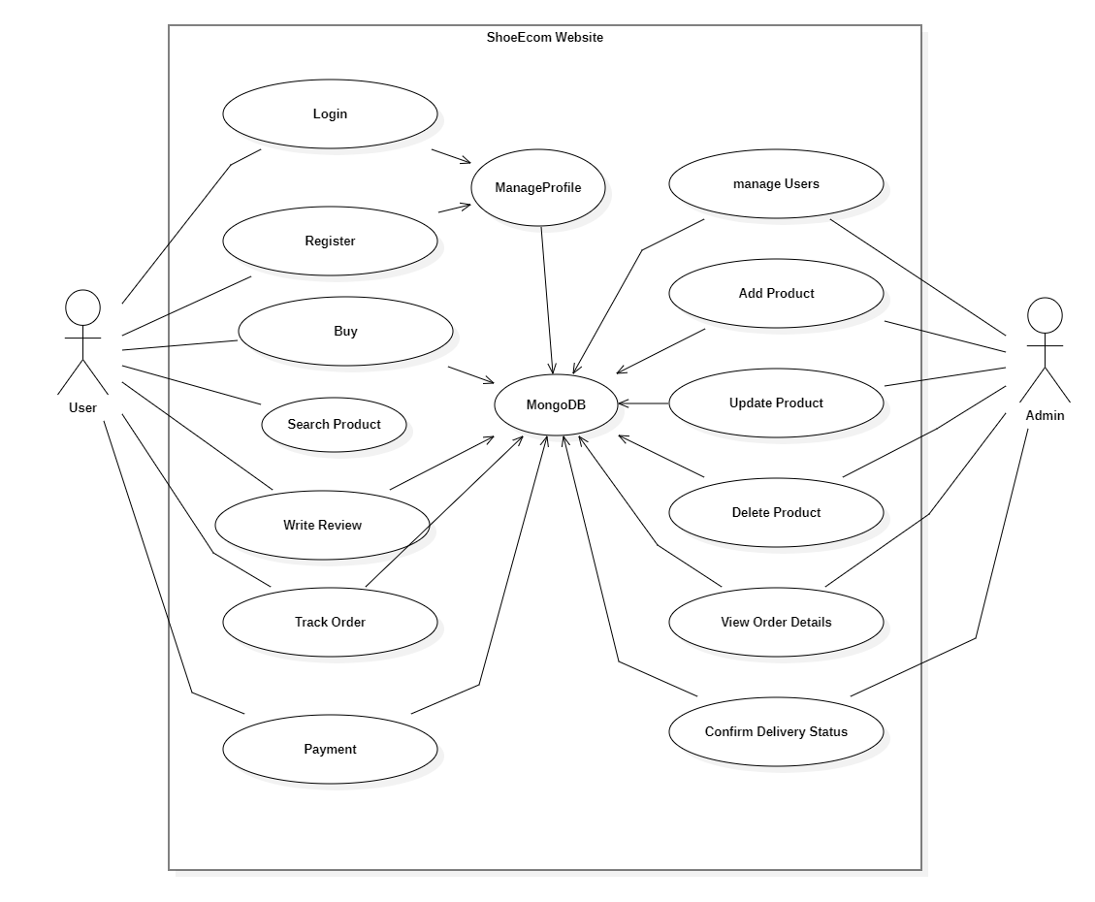

REAL-TIME OBJECT DETECTION

2021-22

Page - 51

* **Activity Diagram of ShoeShop[User Registration]: -**

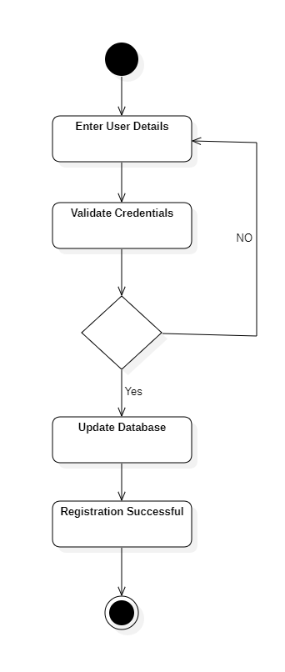

REAL-TIME OBJECT DETECTION

2021-22

Page - 52

* **Activity Diagram of ShoeShop-**

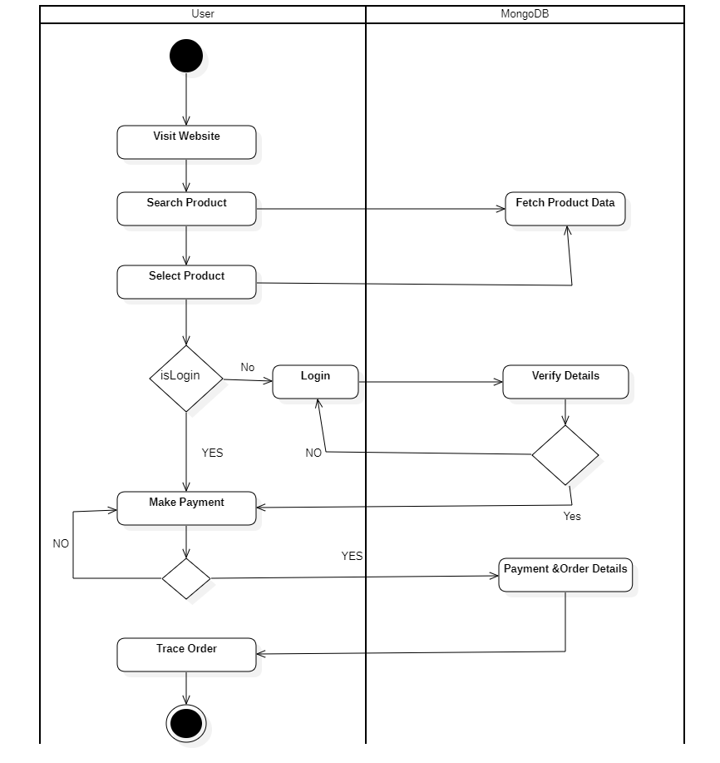

REAL-TIME OBJECT DETECTION

2021-22

Page - 53

* **Activity Diagram of ShoeShop Admin**

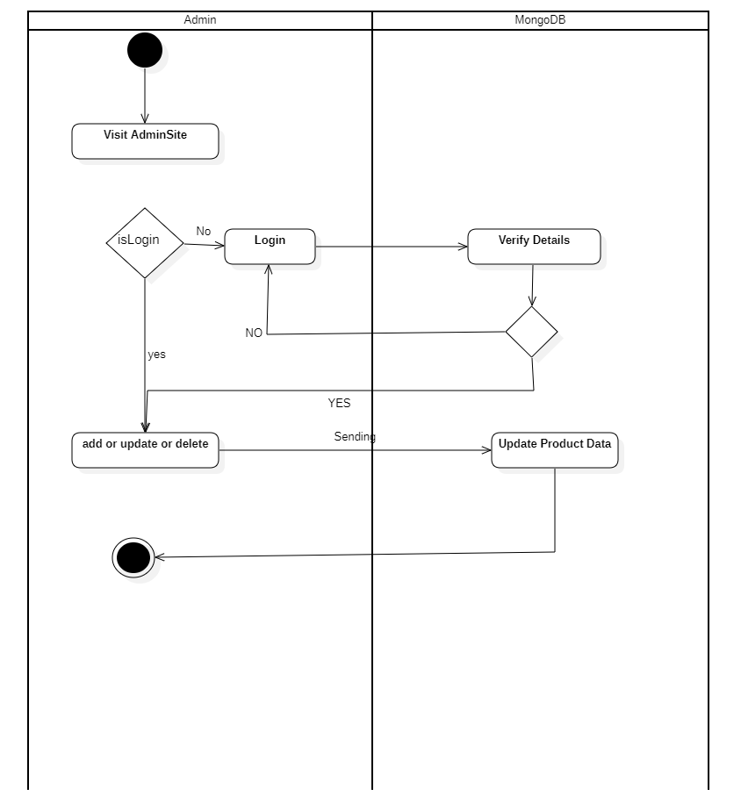

REAL-TIME OBJECT DETECTION

2021-22

Page - 55

* **Sequence Diagram of Real-Time Object Detection (RTOD) -**

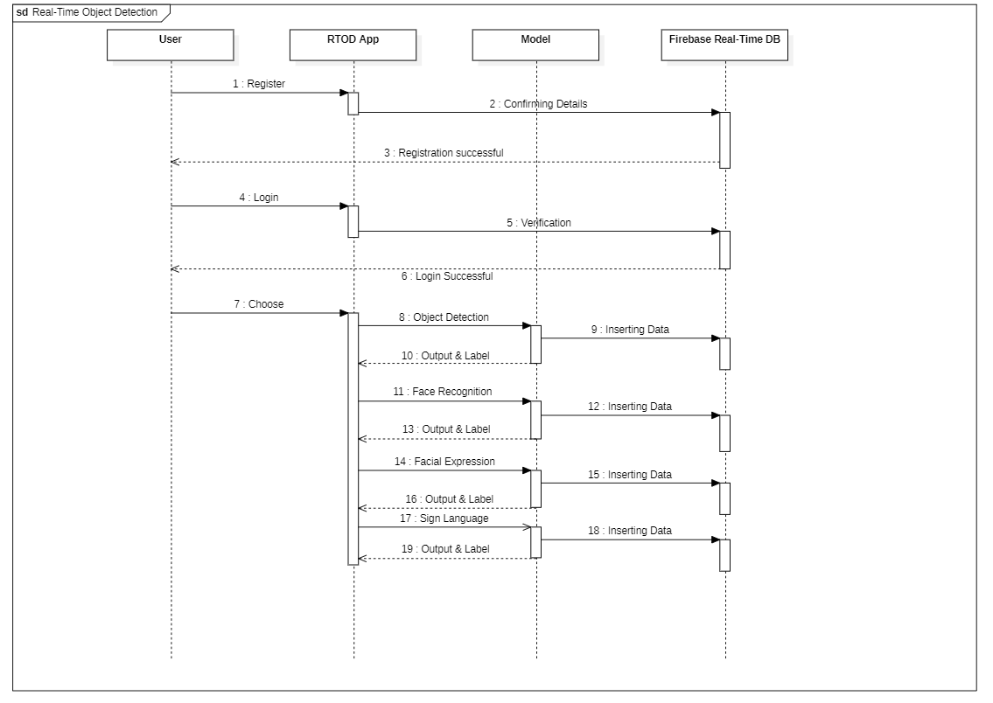

REAL-TIME OBJECT DETECTION

2021-22

Page - 56

REAL-TIME OBJECT DETECTION

2021-22

Page - 57

**4. SYSTEM DESIGN**

**Data Element Dictionary: -**

A data dictionary, also called a data definition matrix, provides detailed information about the business data, such as standard definitions of data elements, their meanings, and allowable values. While a conceptual or logical entity relationship diagram will focus on the high-level business concepts, a data dictionary will provide more detail about each attribute of a business concept.

Essentially, a data dictionary provides a tool that enables you to communicate business stakeholder requirements in such a way that your technical team can more easily design a relational database or data structure to meet those requirements. It helps avoid project mishaps such as requiring information in a field that a business stakeholder can’t reasonably be expected to provide, or expecting the wrong type of information in a field.

A data dictionary provides information about each attribute, also referred to as fields, of a data model. An attribute is a place in the database that holds information. A data dictionary is typically organized in a spreadsheet format. Each attribute is listed as a row in the spreadsheet and each column labels an element of information that is useful to know about the attribute. Data element definition is a human readable phrase or sentence associated with a data element within a data dictionary that describes the meaning or semantics of a data element. Data element definitions are critical for external users of any data system. Good definitions can dramatically ease the process of mapping one set of data into another set of data. This is a core feature of distributed computing and intelligent agent development.

The data element dictionary (D.E.D) is organized into several major sections containing detailed specifications of the data elements relating to the curricular, student, physical facilities, and multiple applications and admissions database (M.A.A.D) data areas. Each of these sections is prefaced by an explanation of the data element combinations that constitute a logically complete record for that particular data area.

REAL-TIME OBJECT DETECTION

2021-22

Page - 58

These general remarks are followed by a diagram depicting a logical data record, a logical listing, an alphabetical listing of the data elements contained in the given data area and the specification sheets for each data element in the given data subset. The logical listings present the data elements in groupings which highlight the bases upon which the elements are inter-related. These logical listings do not represent a magnetic tape layout nor do they reflect a fixed set of data applications; instead, the logical listings are intended to facilitate user understanding of the data elements within the (D.E.D). It should be noted that the data element specification sheets are ordered and numbered in logical sequence rather than alphabetical order. The alphabetical indices of the data elements in this (D.E.D) also contain the page number on which each data element is described. These indices should be useful to anyone desiring to reference a particular data element on a selective basis. Each data element is defined in detail on a data element specification sheet. As for this project I’ve used the firebase cloud store database system so this database is basically a (NoSQL) database system. Firebase performance provides insights into the project performance and the latencies the user’s experience. Firebase Storage provides secure file uploads and downloads for Firebase apps, regardless of network quality, to be used for storing images, audio, video, or other user-generated content. It is backed by Google cloud storage. A (NoSQL) database provides a mechanism for storage and retrieval of data that is modelled in means other than the tabular relations used in the relational database. (NoSQL) databases are increasingly used in big data and real-time web applications. (NoSQL) systems are also sometimes called "Not Only SQL" to emphasize that they may support SQL - like query languages. The particular suitability of a given (NoSQL) database depends on the problem it must solve. Sometimes the data structures used by (NoSQL) databases are also viewed as "more flexible" than relational database tables.

REAL-TIME OBJECT DETECTION

2021-22

Page - 59

**4.2) Table Design:** ‑

* **Database system for Orders**

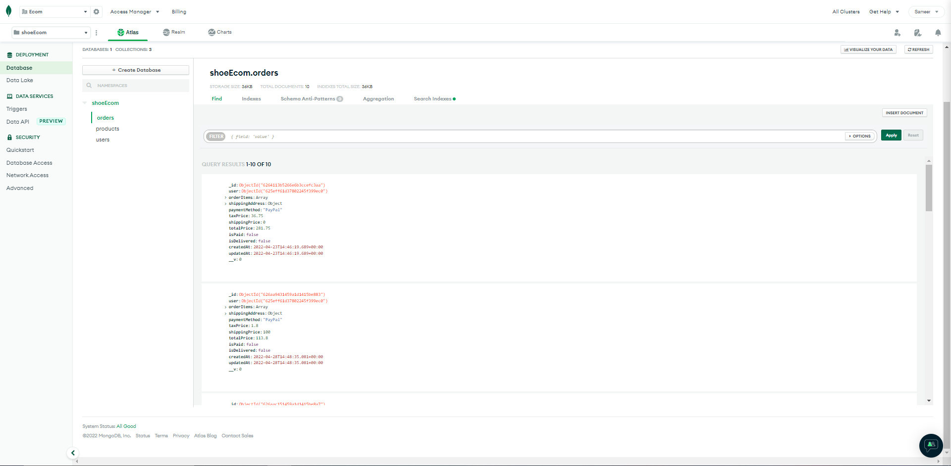

REAL-TIME OBJECT DETECTION

2021-22

Page - 59

* **Database system for Products**

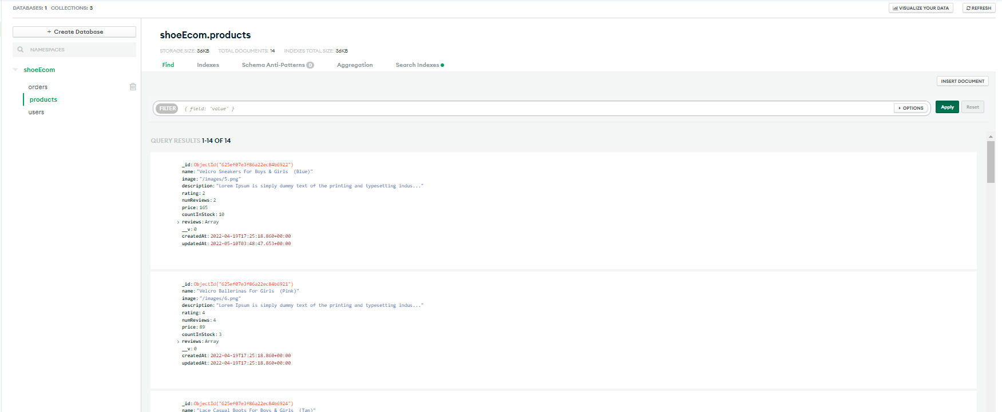

* **Database system for Users**

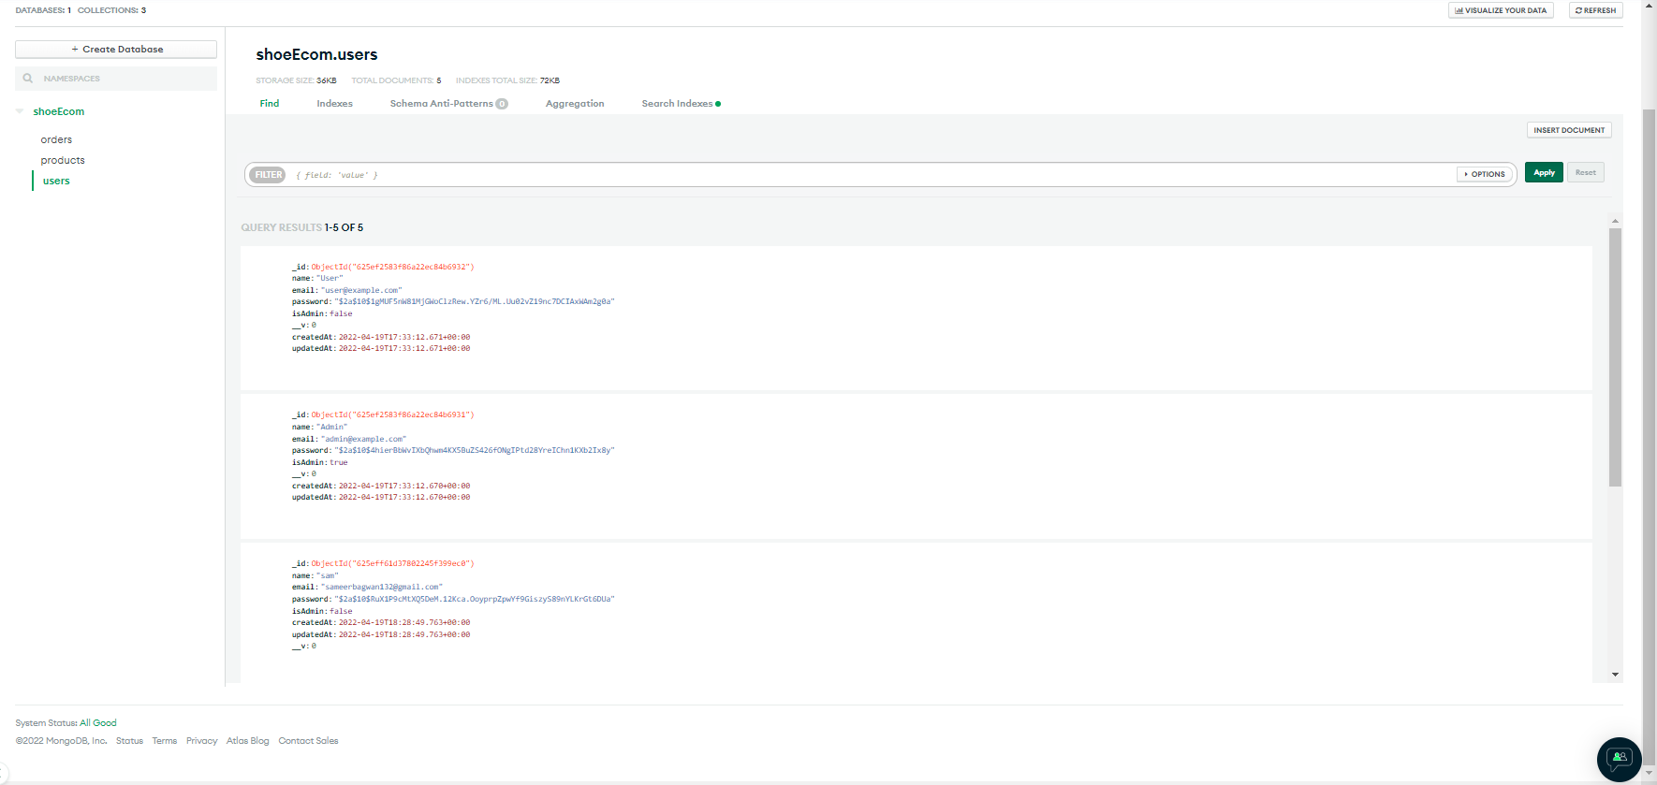

REAL-TIME OBJECT DETECTION

2021-22

Page - 61

**4.3) Program Specification: -**

* **About Program: -**

Object detection has been attracting increasing amounts of attention in recent years due to its wide range of applications and recent technological breakthroughs. This task is under extensive investigation in both academia and real-world applications. Nowadays Smartphone using face recognition for face unlock

REAL-TIME OBJECT DETECTION

2021-22

Page - 62

**Front End**

* **JavaScript:-**

JavaScript was initially created to “make web pages alive”. The programs in this language are called scripts. They can be written right in a web pages (H.T.M.L) and run automatically as the page loads. Scripts are provided and executed as plain text. They don’t need special preparation or compilation to run. In this aspect, java script is very different from another language called java. Today, java script can execute not only in the browser, but also on the server, or actually on any device that has a special program called the java script engine. The browser has an embedded engine sometimes called a “Java Script virtual machine”. Different engines have different “codenames”. For example:

o V8 – in chrome and opera.

o Spider Monkey – in firefox.

o There are other codenames like “Trident” and “Chakra” for different versions of (I.E), “Chakra Core” for Microsoft Edge, “Nitro” and “Squirrelfish” for Safari, etc.

The terms above are good to remember because they are used in developer articles on the internet. We’ll use them too. For instance, if “a feature X is supported by V8”, then it probably works in chrome and opera. Modern java script is a “safe” programming language. It does not provide low-level access to memory or (C.P.U), because it was initially created for browsers which do not require if. java script’s capabilities greatly depend on the environment it’s running in. For instance, node.js supports functions that allow java script to read / write arbitrary files, perform network requests, etc. In browser java script can do everything related to webpage manipulation, interaction with the user, and the webserver. For instance, inbrowser java script is able to add new (H.T.M.L) to the page, change the existing content, and modify styles. React to user actions, run on mouse clicks, pointer movements, key presses. Send requests over the network to remote servers, download and upload files so - called (A.J.A.X) and (C.O.M.E.T) technologies. Get and set cookies, ask questions to the visitor, show messages.

Remember the data on the client-side (“local storage”). JavaScript’s abilities in the browser are limited for the sake of the user’s safety. The aim is to prevent an evil webpage from accessing private information or harming the user’s data. Examples of such restrictions include: java script on a webpage may not read/write arbitrary files on the hard disk, copy them or execute programs. It has no direct access to (O.S) functions. Modern browsers allow it to work with files, but the access is limited and only provided if the user does certain actions, like “dropping” a file into a browser window or selecting it via an <input> tag. There are ways to interact with camera / microphone and other devices, but they require a user’s explicit permission.

So, a java script - enabled page may not sneakily enable a web - camera, observe the surroundings and send the information to the sub differential tabs/windows generally do not know about each other. Sometimes they do, for example when one window uses java script to open the other one. But even in this case, java script from one page may not access the other if they come from different sites from a different domain, protocol or port. This is called the “Same Origin Policy”. To work around that, both pages must agree for data exchange and contain a special java script code that handles it. We’ll cover that in the tutorial. This limitation is, again, for the user’s safety. A page from which a user has opened must not be able to access another browser tab and steal information from there. JavaScript can easily communicate over the net to the server where the current page came from. But its ability to receive data from other sites / domains is crippled. Though possible, it requires explicit agreement expressed in (H.T.T.P) headers from the remote side. Once again, that’s a safety limitation.

**ReactJS (For Admin Website): -**

The react is an open source javascript library for building interfaces. It is maintained by facebook and a community of individual developers and companies. The react can be used as a base in the development of single page or mobile applications. React makes it painless to create interactive (U. I’s). Design simple views for each state in your application, and react will efficiently update and render just the right components when your data changes. React can also render on the server using node and power mobile apps using react native.

REAL-TIME OBJECT DETECTION

2021-22

Page - 63

REAL-TIME OBJECT DETECTION

2021-22

Page - 66

**Back End**

* **MongoDB: -**

MongoDB is a source-available cross-platform document-oriented database program. Classified as a NoSQL database program, MongoDB uses JSON-like documents with optional schemas. MongoDB is developed by MongoDB Inc. and licensed under the Server Side Public License (SSPL).

MongoDB provides high availability with replica sets A replica set consists of two or more copies of the data. Each replica-set member may act in the role of primary or secondary replica at any time. All writes and reads are done on the primary replica by default. Secondary replicas maintain a copy of the data of the primary using built-in replication. When a primary replica fails, the replica set automatically conducts an election process to determine which secondary should become the primary. Secondary can optionally serve read operations, but that data is only eventually consistent by default.

If the replicated MongoDB deployment only has a single secondary member, a separate daemon called an *arbiter* must be added to the set. It has a single responsibility, which is to resolve the election of the new primary.As a consequence, an idealized distributed MongoDB deployment requires at least three separate servers, even in the case of just one primary and one secondary

MongoDB can be used as a file system, called GridFS, with load balancing and data replication features over multiple machines for storing files.

This function, called grid file system is included with MongoDB drivers. MongoDB exposes functions for file manipulation and content to developers. GridFS can be accessed using mongofiles utility or plugins for Nginx[33] and lighttpd.  GridFS divides a file into parts, or chunks, and stores each of those chunks as a separate document

REAL-TIME OBJECT DETECTION

2021-22

Page -67

➢ Node.Js Server:

The node.js is an open source, cross platform, javascript runtime environment that executes JavaScript code outside of a web browser. Node.js lets developers use javascript to write command line tools and for server-side scripting running scripts server-side to produce dynamic web page content before the page is sent to the user's web browser. Consequently, node.js represents a javascript everywhere paradigm, unifying web application development around a single programming language, rather than different languages for server and client-side scripts.

Though node.js is the standard filename for javascript code, the name "Node.js" doesn't refer to a particular file in this context and is merely the name of the product. Node.js has an event driven architecture capable of asynchronous i/o. These design choices aim to optimize through put and scalability in web applications with many input/output operations, as well as for real time web applications.

Node.js allows the creation of web servers and networking tools using javascript and a collection of "modules" that handle various core functionalities. Modules are provided for file system i/o, networking, binary data, cryptography functions, data streams, and other core functions. The node.js modules use an (A.P.I) designed to reduce the complexity of writing server applications. Node.js is primarily used to build network programs such as web servers.

REAL-TIME OBJECT DETECTION

2021-22

Page -67

➢ Express.js

Express.js, or simply Express, is a back end web application framework for Node.js, released as free and open-source software under the MIT License. It is designed for building web applications and APIs. [3] It has been called the de facto standard server framework for Node.js. [4] The original author, TJ Holowaychuk, described it as a Sinatra-inspired server,[5] meaning that it is relatively minimal with many features available as plugins. Express is the back-end component of popular development stacks like the MEAN, MERN or MEVN stack, together with the MongoDB database software and a JavaScript front-end framework or library.[6] Express.js was founded by TJ Holowaychuk. The first release, accordin Express.js's GitHub repository, was on 22 May 2010. Version 0.12 In June 2014, rights to manage the project were acquired by StrongLoop. [7] StrongLoop was acquired by IBM in September 2015;[8] in January 2016, IBM announced that it would place Express.js under the stewardship of the Node.js Foundation incubator.[9]

➢ Features

• Robust routing

• Concentrate on high-performance

• HTTP helpers (redirection, caching, etc)

• Content negotiation

REAL-TIME OBJECT DETECTION

2021-22

Page -67

➢ **Software’s Being Used For Development & Website: -**

* **Visual Studio Code** :-

Visual Studio Code, also commonly referred to as VS Code, [9] is a source-code editor made by Microsoft for Windows, Linux and macOS. [10] Features include support for debugging, syntax highlighting, I ntelligent code completion, snippets, code refactoring, and embedded Git. Users can change the theme, keyboard shortcuts, preferences, and install extensions that add additional functionality.

In the Stack Overflow 2021 Developer Survey, Visual Studio Code was ranked the most popular developer environment tool, with 70% of 82,000 respondents reporting that they use it

Visual Studio Code is a source-code editor that can be used with a variety of programming languages, including Java, JavaScript, Go, Node.js, Python and C++. It is based on the Electron framework,[20] which is used to develop Node.js Web applications that run on the Blink layout engine. Visual Studio Code employs the same editor component (codenamed "Monaco") used in Azure DevOps (formerly called Visual Studio Online and Visual Studio Team Services).

Out of the box, Visual Studio Code includes basic support for most common programming languages. This basic support includes syntax highlighting, bracket matching, code folding, and configurable snippets. Visual Studio Code also ships with IntelliSense for JavaScript, TypeScript, JSON, CSS, and HTML, as well as debugging support for Node.js. Support for additional languages can be provided by freely available extensions on the VS Code Marketplace.

REAL-TIME OBJECT DETECTION

2021-22

Page -67

* **Const**: **:-**
* ContactInfo
* Pagination
* Rating
* Shopsection
* Message
* Loading
* Toast
* Orders
* ProfileTabs
* submitHandler
* userDetails
* userUpdateProfile
* products
* users
* DataModels
* Protect
* notFound
* OrderModel
* UsersModels
* OrderRoutes
* UsersRoutes
* ProductsRoutes
* ImportData

REAL-TIME OBJECT DETECTION

2021-22

Page - 68

* **Function**: **:-**
* addTOCart
* setItem
* removefromcart
* saveShippingAddress
* savePaymentMethod
* createOrders
* removeItem
* getOrderDetails
* payOrder
* listMyOrder
* getState
* listProduct
* listProductDetails
* createProductReview
* login
* logout
* register
* getUserDetails
* updateUserProfile
* PrivateRouter
* ProductsStatistics
* orderItem

REAL-TIME OBJECT DETECTION

2021-22

Page - 69

* SaleStatistics
* connectDatabase
* admin
* errorHandler
* orderSchema
* reviewSchema
* productSchema
* userSchema
* asyncHandler
* status
* createOrder
* updateOrder
* delete
* post
* put
* userRoute
* productRoute
* insertMany
* createUser
* createProducts
* removeProducts

**4.4) Input Screen Design (Alexa Mobile Application): -**

* **HomeScreen1**:

REAL-TIME OBJECT DETECTION

2021-22

Page - 70

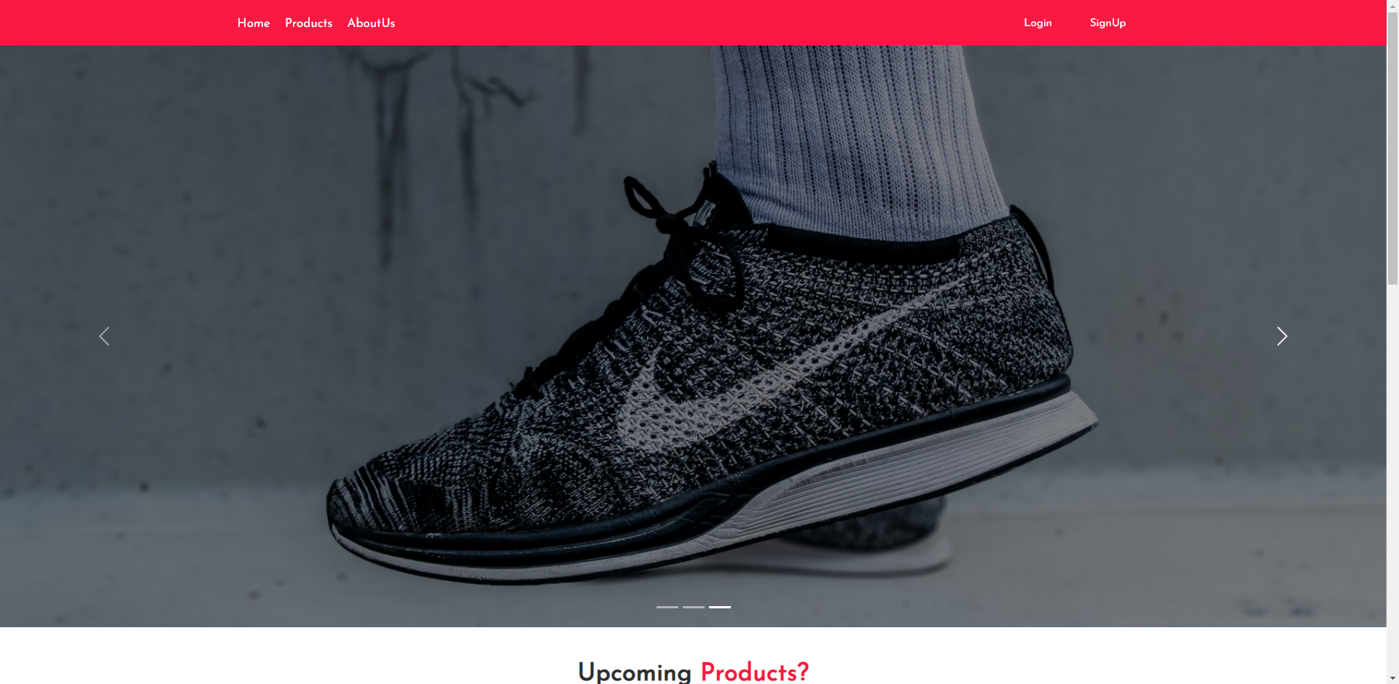

REAL-TIME OBJECT DETECTION

2021-22

Page - 71

* **Homescreen2**:

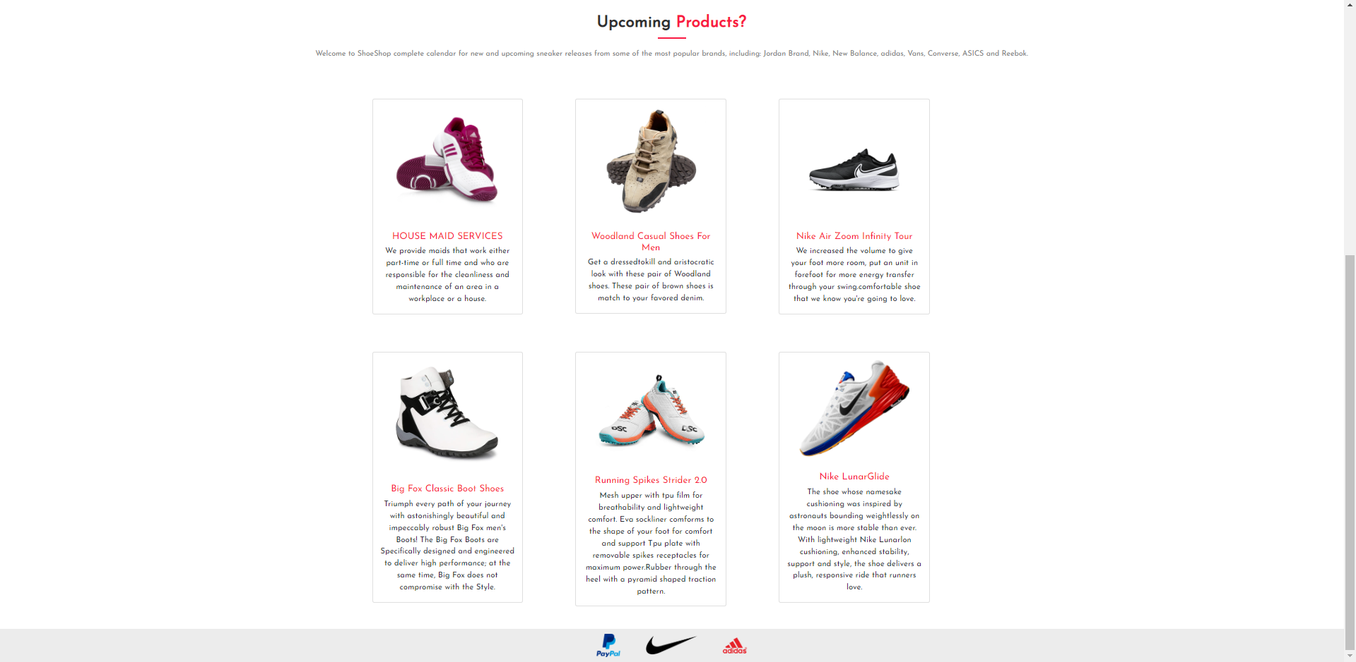

* **Screen for Products:**

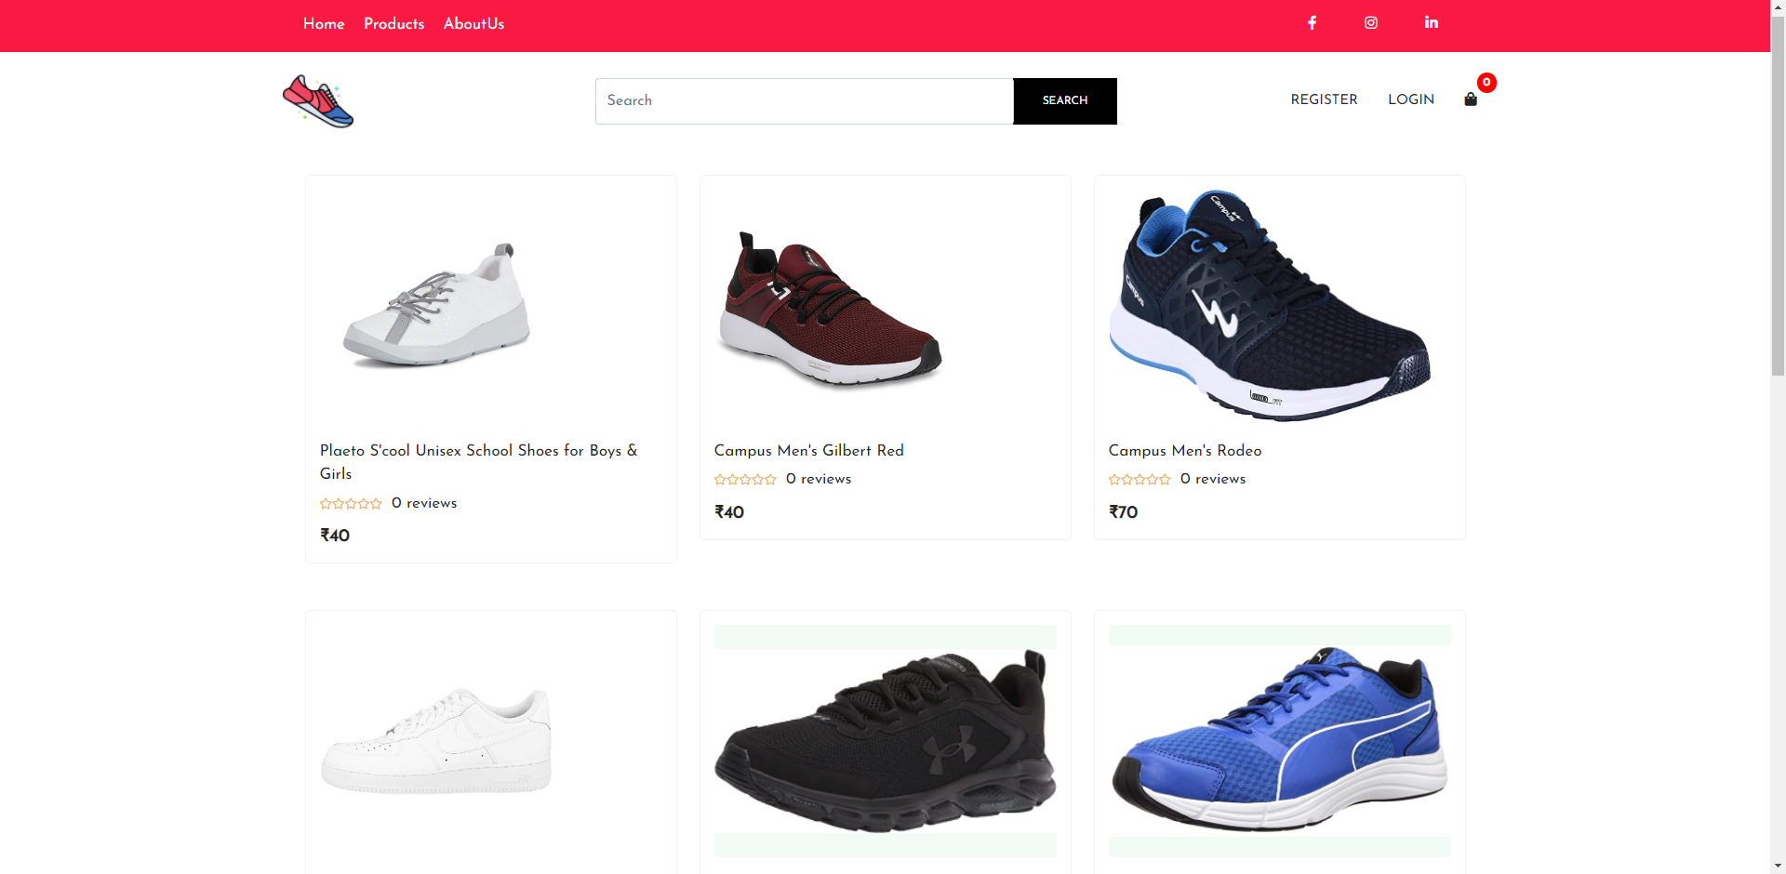

REAL-TIME OBJECT DETECTION

2021-22

Page - 72

REAL-TIME OBJECT DETECTION

2021-22

Page - 73

* **Screen for Single Product**

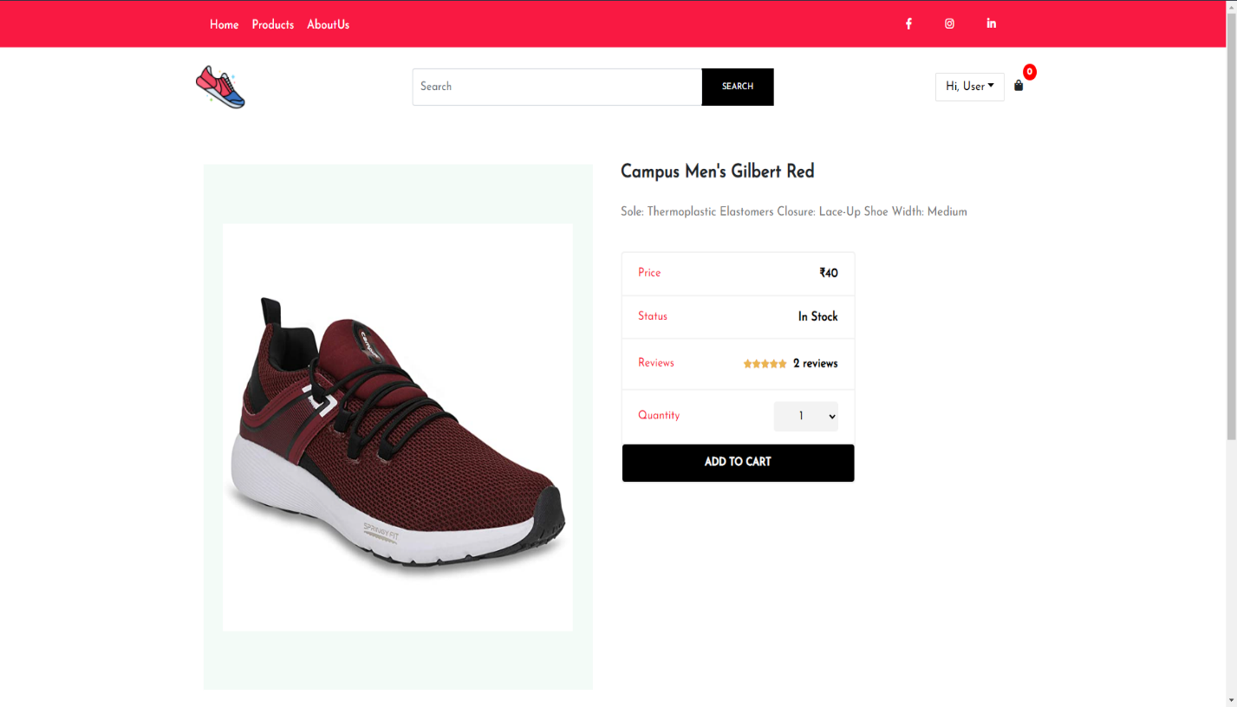

REAL-TIME OBJECT DETECTION

2021-22

Page - 74

* **Review of Products:**

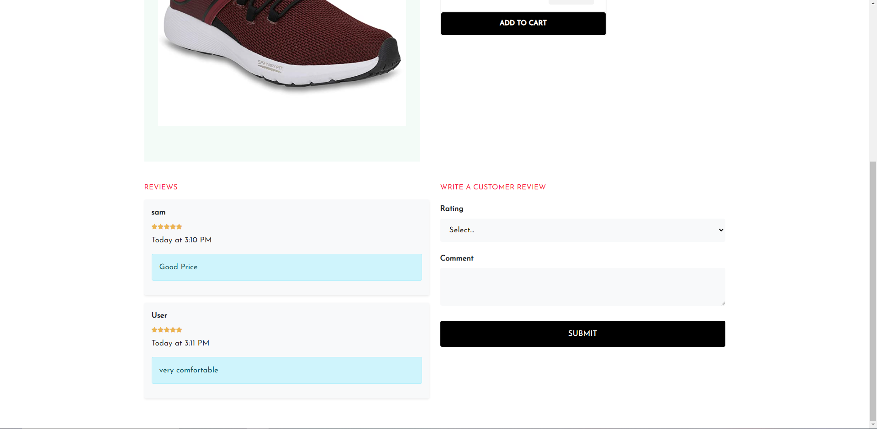

REAL-TIME OBJECT DETECTION

2021-22

Page - 75

* **Login Screen:**

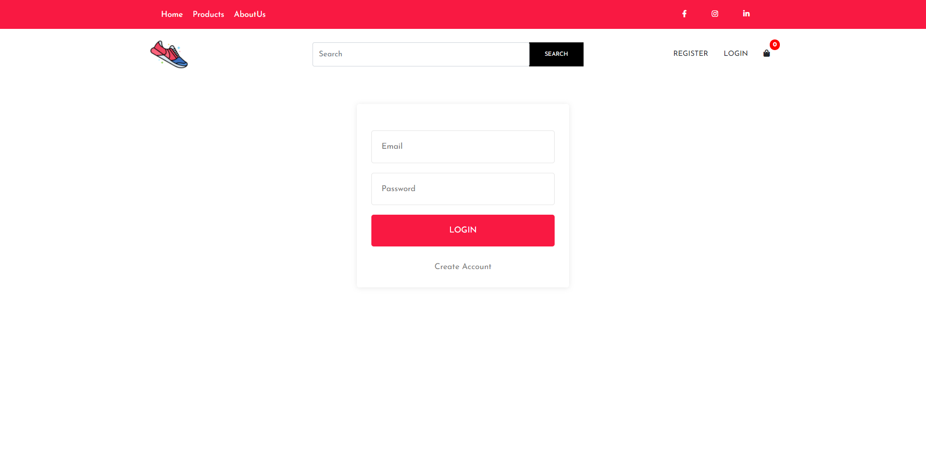

REAL-TIME OBJECT DETECTION

2021-22

Page - 76

* **Register Screen:**

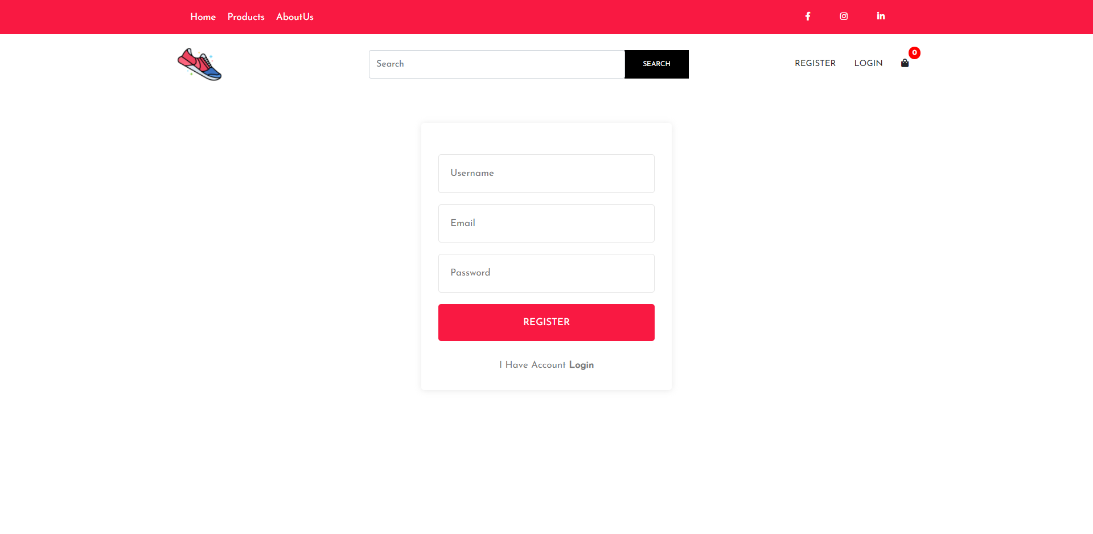

REAL-TIME OBJECT DETECTION

2021-22

Page - 77

* **Cart Screen:**

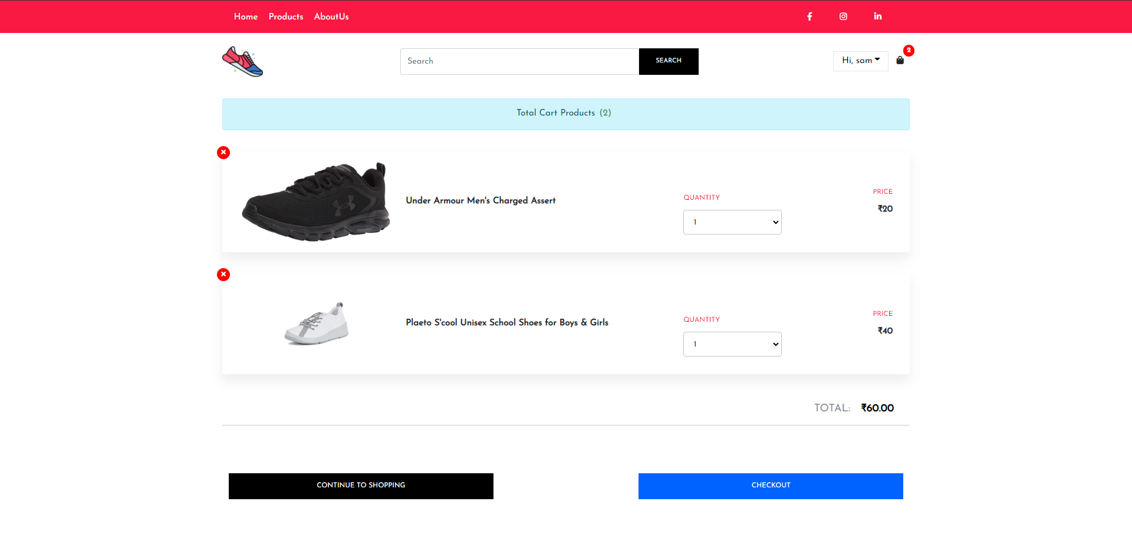

* **Cart Screen:**

REAL-TIME OBJECT DETECTION

2021-22

Page - 77

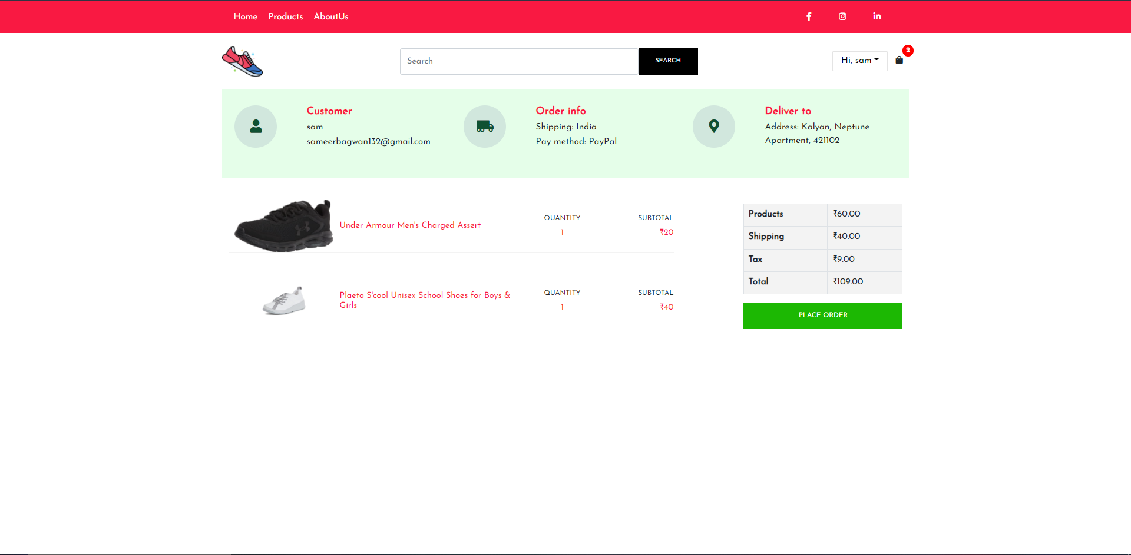

REAL-TIME OBJECT DETECTION

2021-22

Page - 77

* **Address Screen:**

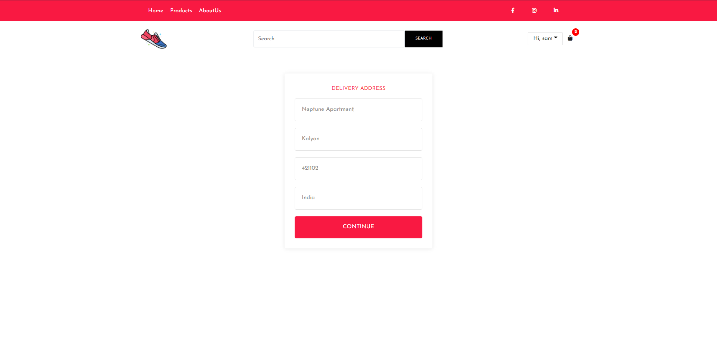

* **User Details Screen:**

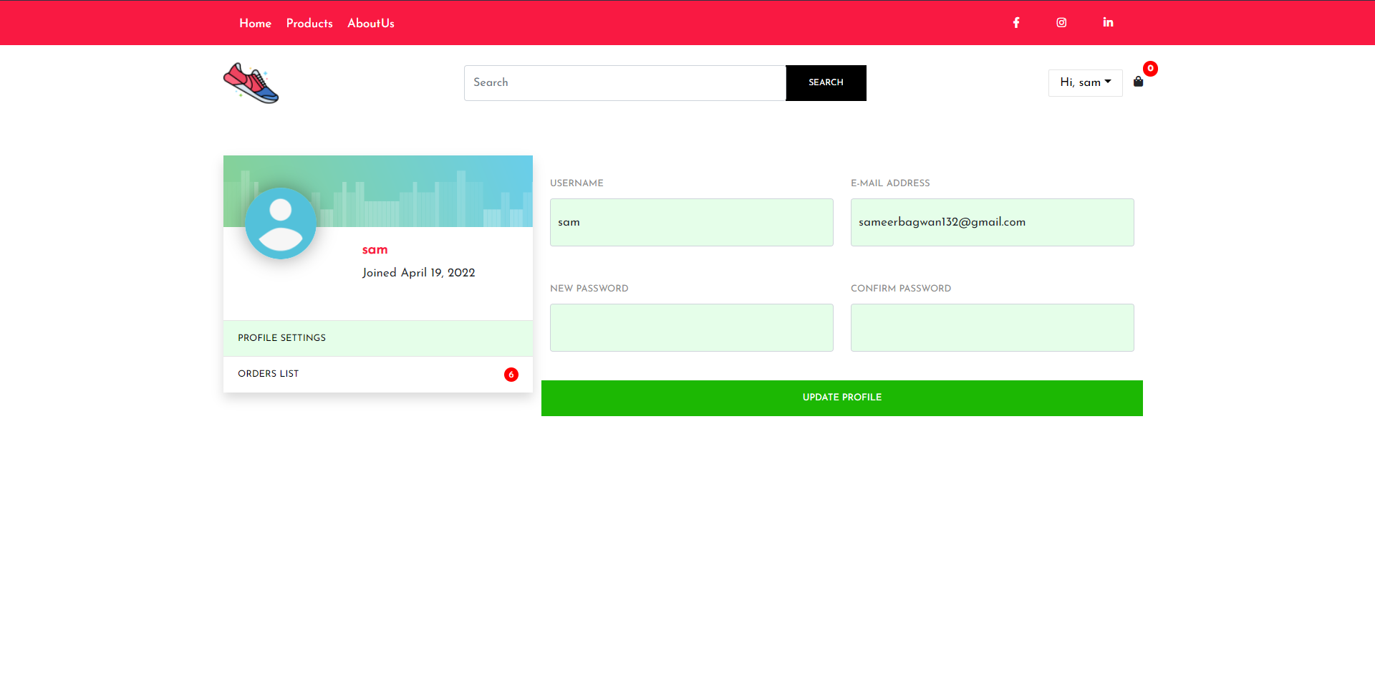

* **User OrderList Screen:**

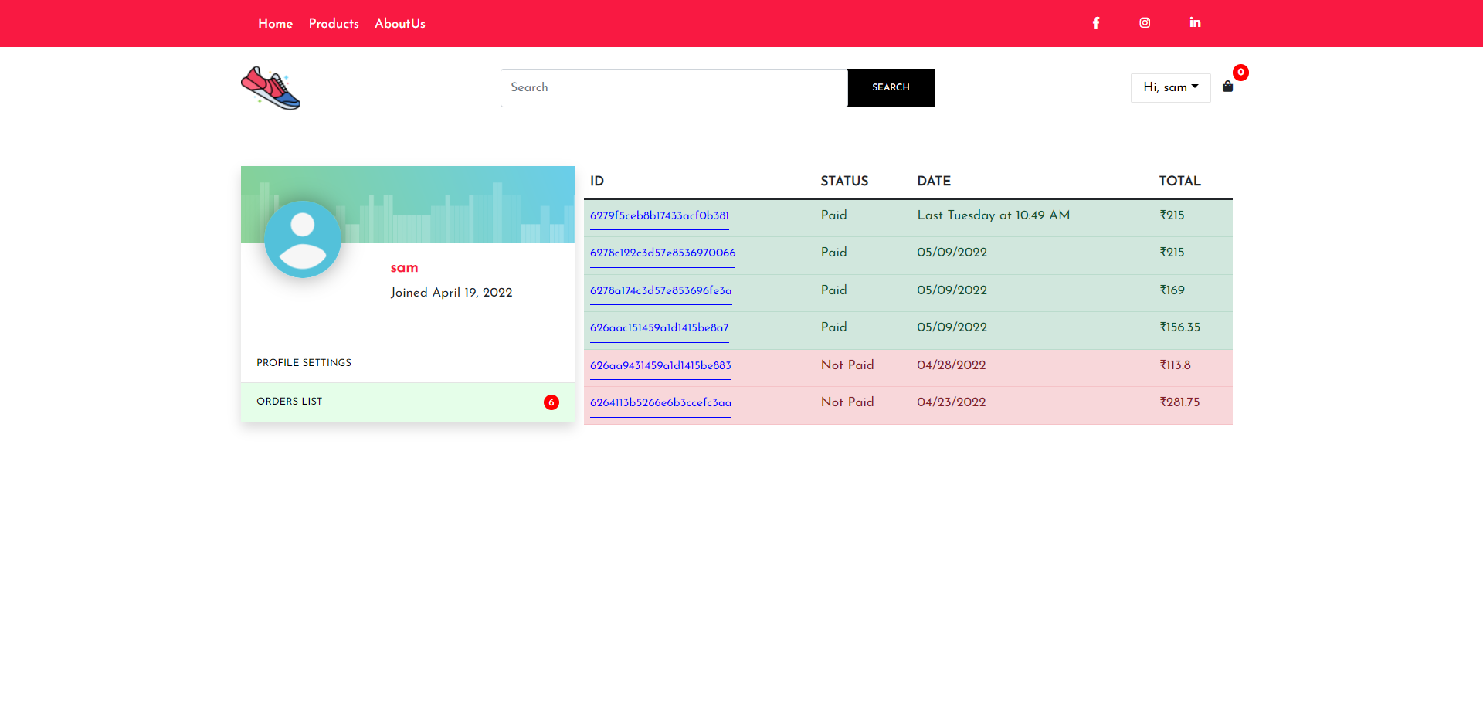

REAL-TIME OBJECT DETECTION

2021-22

Page - 77

* **Pre Payment Screen:**

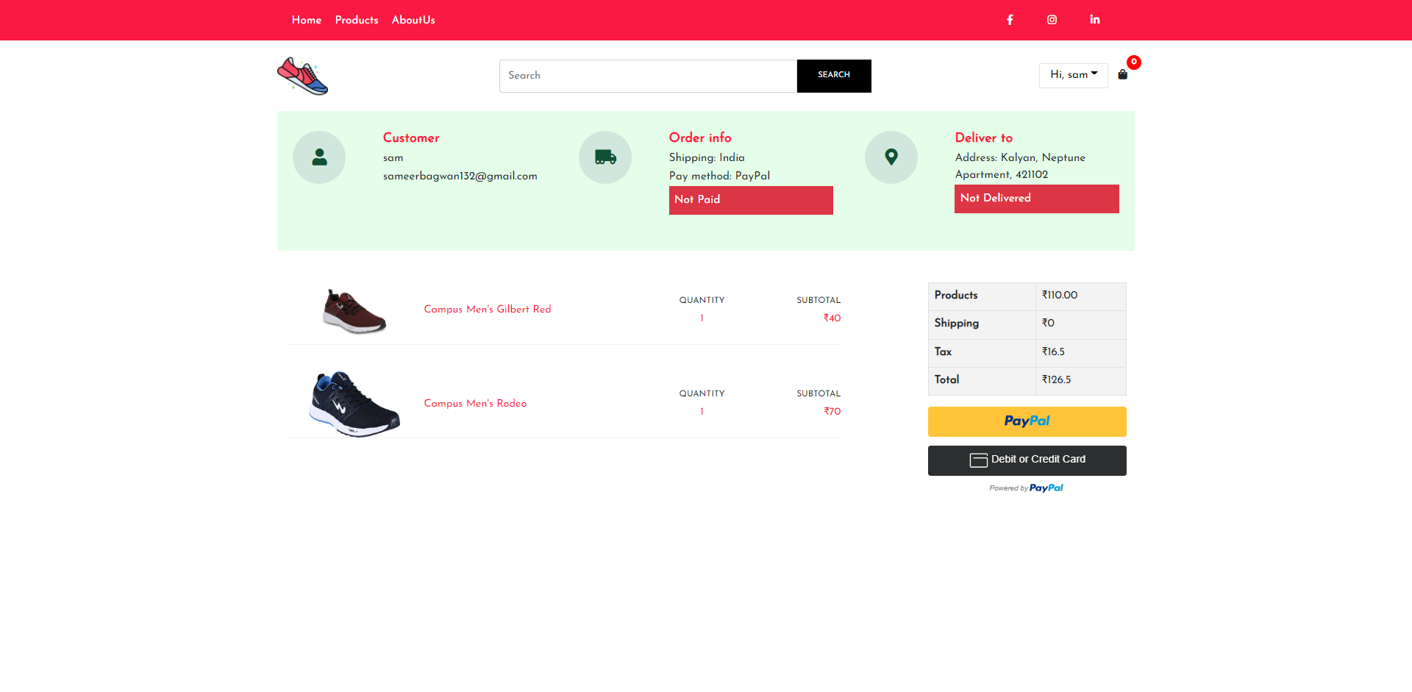

* **Payment Screen:**



REAL-TIME OBJECT DETECTION

2021-22

Page - 77

REAL-TIME OBJECT DETECTION

2021-22

Page - 77

* **Order Placed Screen:**

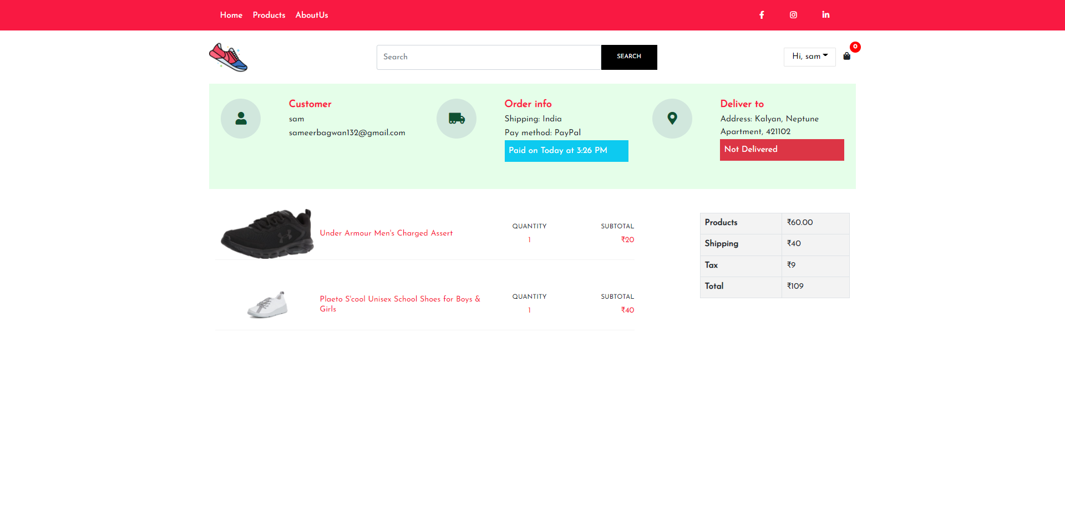

REAL-TIME OBJECT DETECTION

2021-22

Page - 78

**5. TESTING PROCEDURES**

Testing, as the final stage of the development of the website, plays a vital role in the process of creating high-quality software. After the website testing, the customer is provided with a ready project without errors, with good readability, perceived ease, convenience, and reliability. The basic rules for testing of a website are steps that show the user how easy and logical the project is, how easy and possible to find the required information. The more complex the site, the more time it takes to test it and debug it. Depending on the specifics of the project, up to 50% of the total budget and time resources can be allocated to test a website.To organize the testing of the website, a specially developed methodology is provided. The verification of your website is carried out according to this methodology. Testing can occur in a variety of ways, but do not forget about the process itself and the testing strategy. The sequence of your actions depends on it.

➢ **Documentation testing**

We should start with the preparatory phase, testing the documentation. The tester studies the received documentation (analyzes the defined site functionality, examines the final layouts of the site and makes a website test plan for further testing).

The main artifacts related to the website testing are analyzed on this stage:

• Requirements

• Test Plan

• Test Cases

• Traceability Matrix

➢ Website functionality testing Functional testing is aimed to ensure that each function of the website operates in conformance with the requirement specification. Website testing of the functionality shows “What the system does”. Let’s try to create the checklist for you website functionality testing.

**You should verify:**

• Outbound links

• Internal links correctness

• There are no links leading to the same page

• The links that are used to send e-mails to site admins

• If there are pages that are not referenced • There are no broken links

REAL-TIME OBJECT DETECTION

2021-22

Page - 77

**Functional and (U.X) Testing:** -

User Experience (UX) Testing, is a testing method for measuring how easy and user-friendly a software application is. A small set of target end-users, use software application to expose usability defects

**Compatibility Testing**

Mobile devices vary between platforms, models, and operating system versions. It's essential to select a subset of devices relevant to your application.

**Security Testing: -**

In parallel, arrange for a third-party lab to conduct a security assessment of your device.

**➢ Beta testing**

**Beta testing –** the final prerelease stage of testing. As a rule, it is done by end-users and out stuff people.

REAL-TIME OBJECT DETECTION

2021-22

Page - 80

**6. OUTPUT SCREENS**

* **Dashboard Screen:**

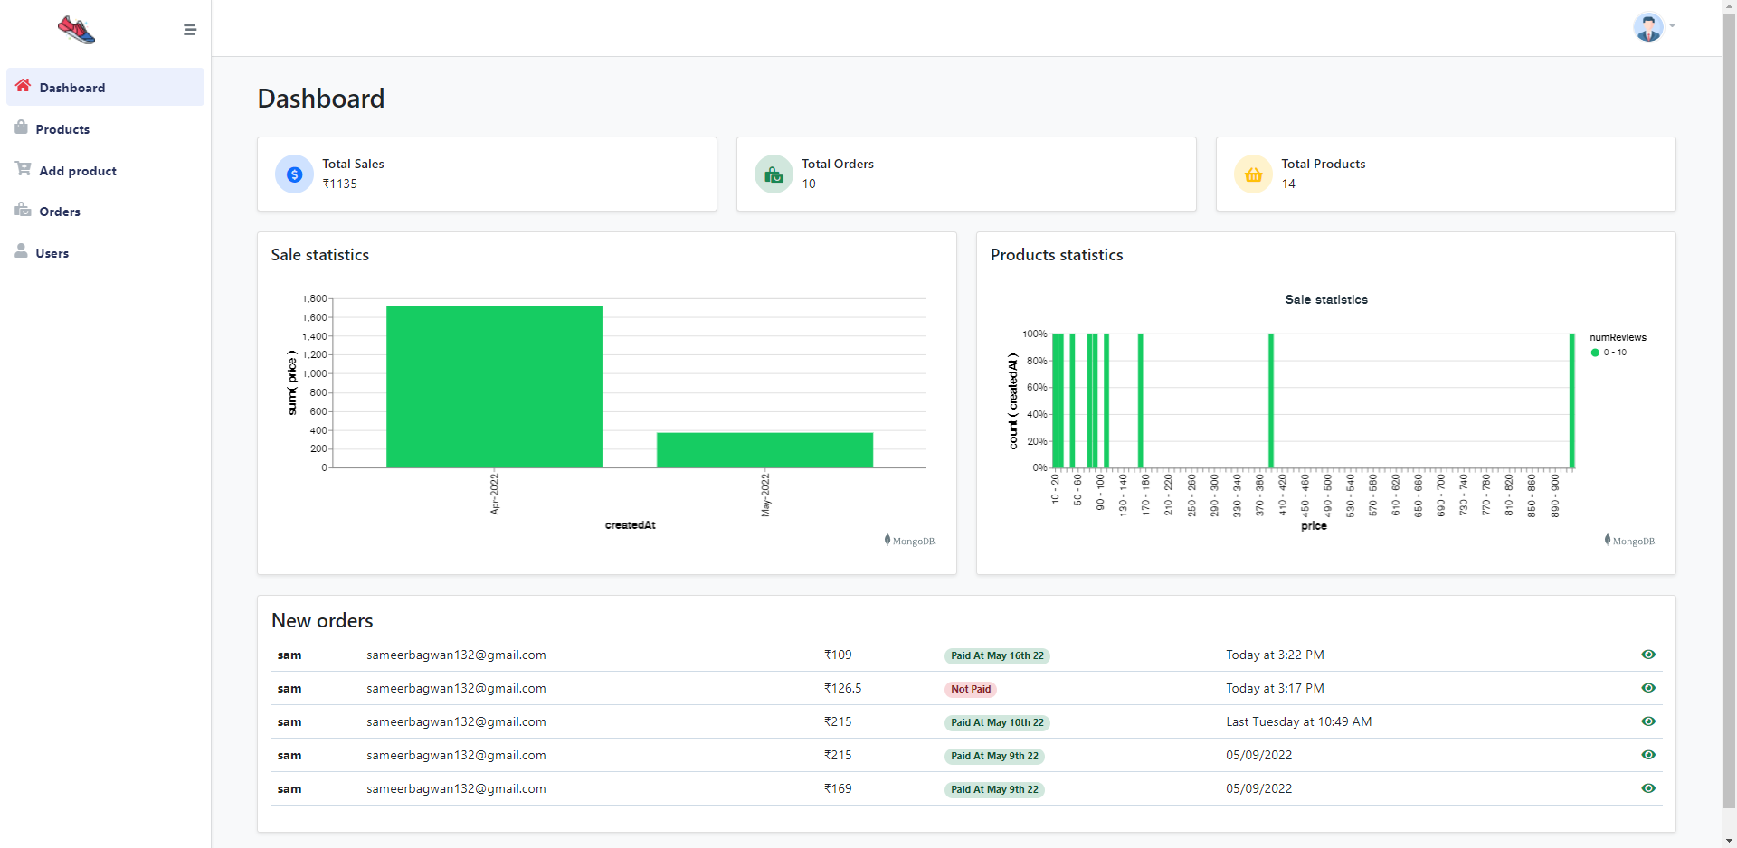

REAL-TIME OBJECT DETECTION

2021-22

Page - 81

* **Add Product Screen:**

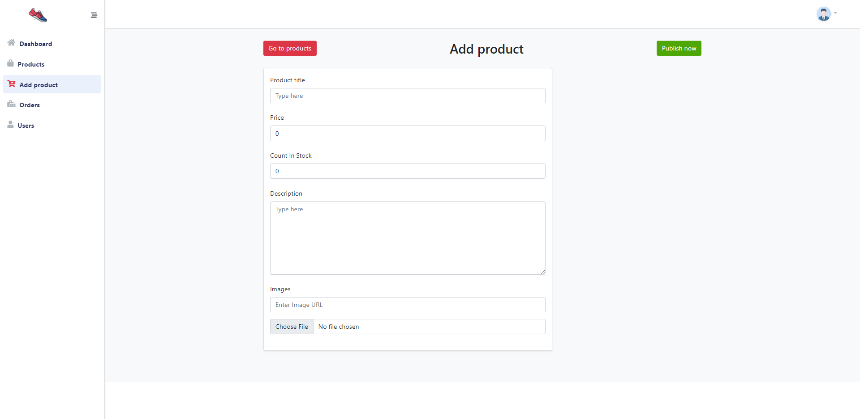

REAL-TIME OBJECT DETECTION

2021-22

Page - 82

* **Edit/Delete Screen:**

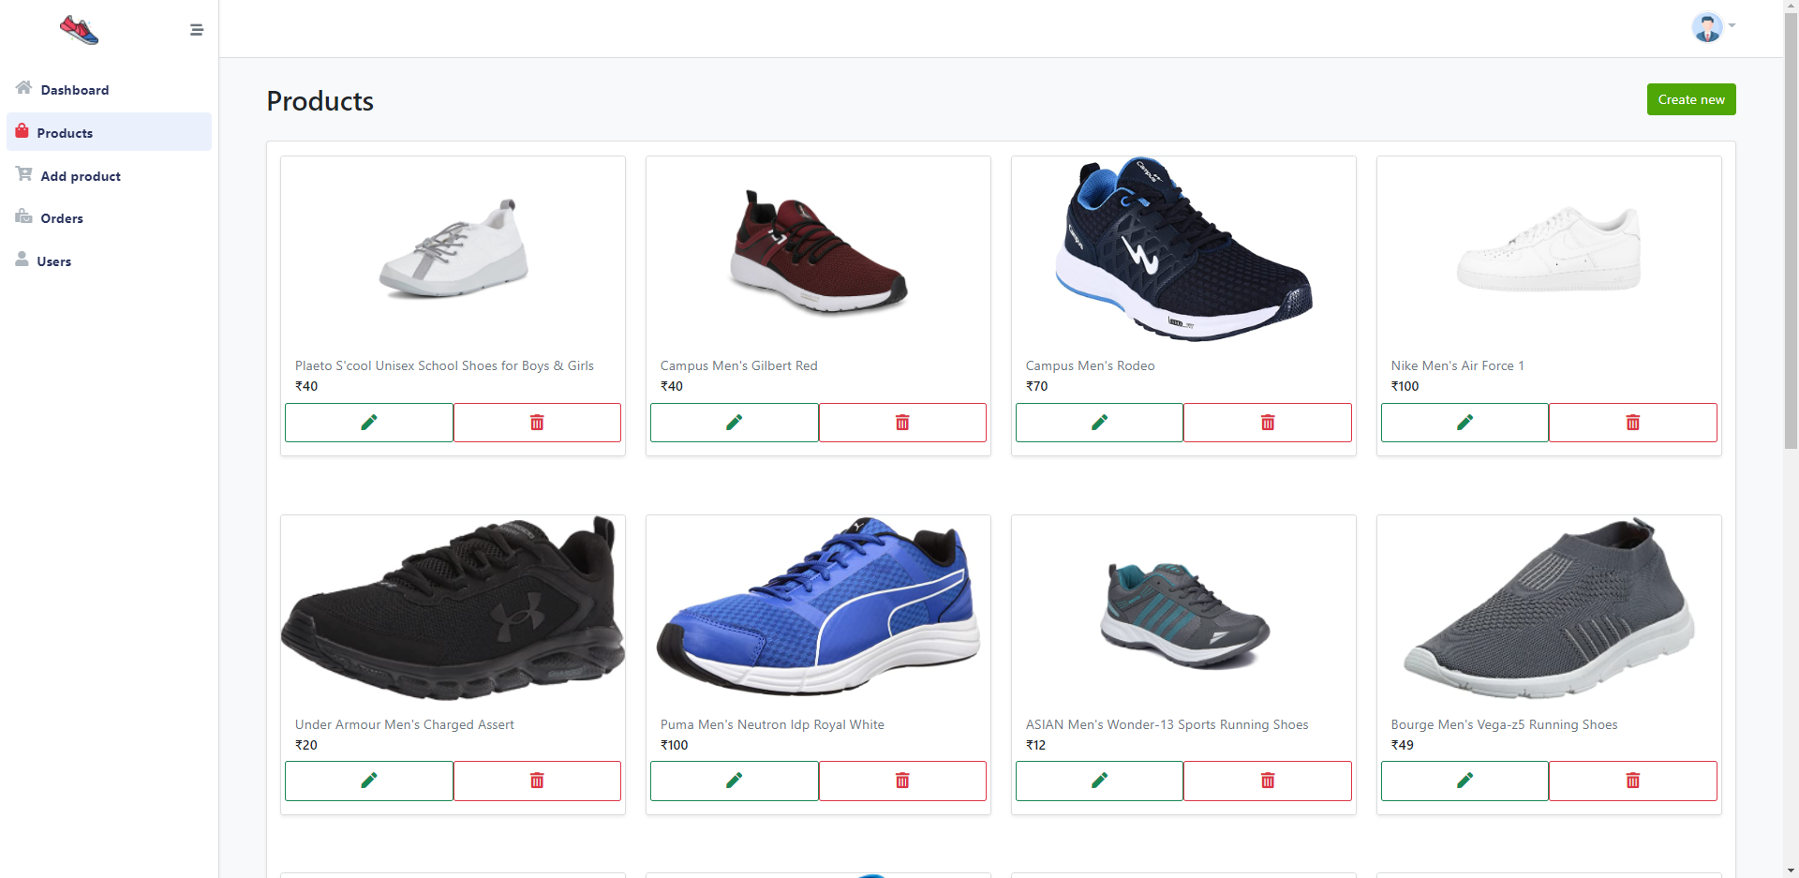

REAL-TIME OBJECT DETECTION

2021-22

Page - 83

* **OrderList Detail Screen:**

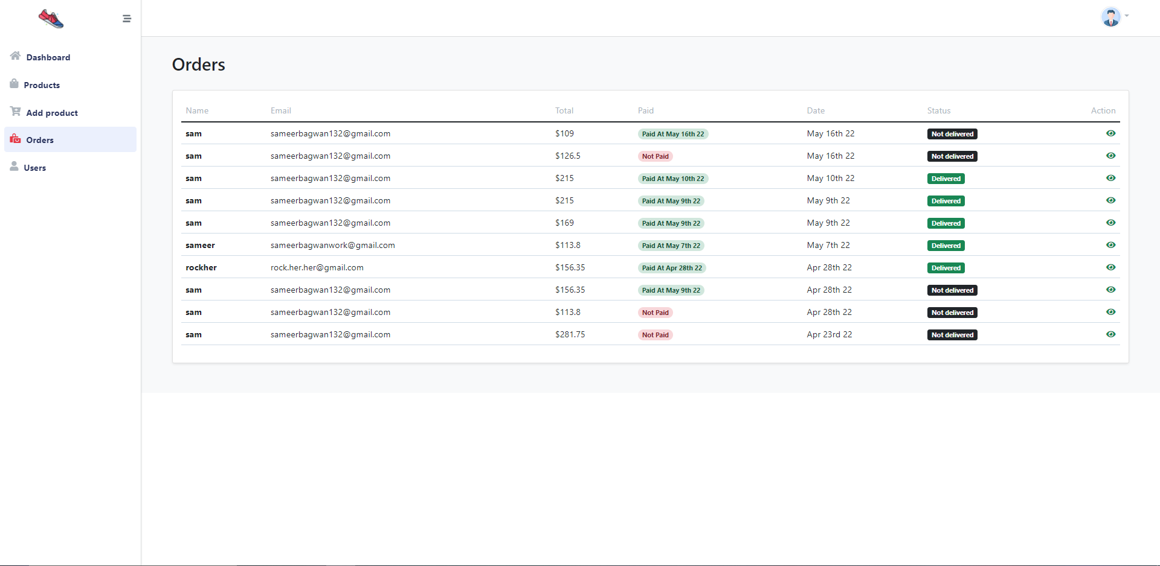

REAL-TIME OBJECT DETECTION

2021-22

Page - 84

* **User List Screen:**

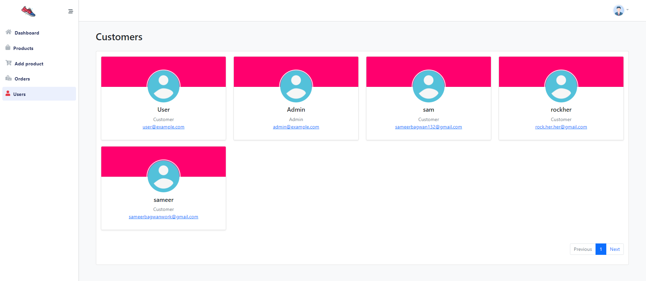

REAL-TIME OBJECT DETECTION

2021-22

Page - 87

**7. IMPLEMENTATION PROCEDURE**

Basically, implementation of this project is first to find best language and tech for this website.second step is to design UI (user interface) for this website after that all I need is to find information that user enter . after implement service page where all services are listed and user can add a particular serives to cart and after that the information related to services is has to stored in database and after fetch into user profile.so, I decide that I can Developed Website using ReactJS(front end), and nodeJs for backend using nodejs fremwork Express that help me a lot. After add to cart page i implement payment getway for payment.because of that payment getway user can pay amount through card or payment app. Because of payment getway that .In this project I used MERN stack . MERN stack is javasccript stack that is used for easier and faster deployment of full-stack web application .MERN Stack comprise of 4 technologies namely : MongoDB,Express,React and Node.js It is designed to make the development process smoother and easier.

Each of these 4 powerful technologies provides an end-to-end framework for the developers to work in and each of these technologies play a big part in the development of web applications.MongoDB offers scalable document-oriented database storage. That makes it ideal for applications requiring real-time scalabilities like large social networks or e-commerce websites.

It stores data in flexible documents rather than rows and columns, so developers can use JavaScript code to operate on data directly instead of needing separate objects between your application & database layer. there’s a lot more flexibility when working with Mongo as opposed to SQL databases. Data are dynamic, schema-free. Documents are not required to have a uniform structure over time. A wide variety of data types are supported by default, with user-defined kinds available. It makes it easy to model more complex data sets than more superficial key/value-based structures.

REAL-TIME OBJECT DETECTION

2021-22

Page - 88

**8. USER MANUAL**

* **You’ll Need To Follow Some Steps: -**
* **For User:**
* **Step 1: -** You have to go Home Page
* **Step 2:**- Then click on product to see all products
* **Step 3: -** Select product to view.
* **Step 4:** - Login if not then Register
* **Step 5: -** Place order
* **Step 6:** -Enter the Address and choose payment Option
* **Step 7:** - Pay with paypal
* **Step 8:** - Track order

**❖ For Admin:**

* **Step 1: -** You have to go to admin website.
* **Step 2: -** To go to login page.
* **Step 3: -** After logging in you’ve got to see Dashboard
* **Step 4: -** you can Add/Delete/Update product
* **Step 5: -** you can see orderList and UserList
* **Step 6: -** you can change Delivery status

REAL-TIME OBJECT DETECTION

2021-22

Page - 89

**9. SCOPE FOR FUTURE ENHANCEMENT**

So, as we all know that today’s world has become too much competitive in all sorts of things. So, whether it be sports, studies, corporate world, etc. We are always in need of an innovative technology because, these technologies do help humans to ease 50 – 80 percent of work. This study can be used widely to provide the blind with privacy and convenience in everyday life.For security reasons, wired serial communications were used instead of a wireless server. If the information is linked to a server, it could be leaked onto the Internet. Since the information in question contains a lot of privacy and camera-based observations, such leaks could create critical security issues for users. However, a wired connection can secure the information by keeping it offline. Continuous research is expected to solve server security problems, eliminate blind spots in observations by connecting Internet of Things (IOT) cameras to a secure network, and increase precision in object recognition .

The Face Recognition (FR) is growing as a major research area because of the broad choice of applications in the fields of commercial and law enforcement. Traditional FR methods based on Visible Spectrum (VS) are facing challenges like object illumination, pose variation, expression changes, and facial disguises. Unfortunately these limitations decrease the performance in object identification and verification. To overcome all these limitations, the Infrared Spectrum (IRS) may be used in human FR. So it leads and encourages the researchers for continuous research in this area of FR. Simultaneously, the present study emphasizes the use of three dimensional cubic dataset i.e. Multi/ Hyperspectral Imagery Data in FR. The IR based Multi/ Hyperspectral Imaging System can minimize the several limitations arise in the existing and classical FR system because the skin spectra derived with cubic dataset depicts the unique features for an individual. Multi/ Hyperspectral Imaging System provides valuable discriminants for individual appearance that cannot be obtained by additional imaging system that's why this may be the future of human FR. This paper also presents a detailed and time to time review of the literature on FR in IRS.

REAL-TIME OBJECT DETECTION

2021-22

Page - 90

The proposed sign language recognition system used to recognize sign language letters can be further extended to recognize gestures facial expressions. Instead of displaying letter labels, it will be more appropriate to display sentences as more appropriate translation of language. This also increases readability. The scope of different sign languages can be increased. More training data can be added to detect the letter with more accuracy. This project can further be extended to convert the signs to speech.

In coming future this project will definitely help students, college faculties, universities, Mute communites to grow. And this project does have a big scope in future because nowadays we all are getting smart day by day and with such a thing coming into the market it will definitely help people.

REAL-TIME OBJECT DETECTION

2021-22

Page - 91

**10. CONCLUSION**

In this paper, a model, which was using the SSD algorithm, was made use for creating an application for object detection, which uses TensorFlow object detection API for working offline, and giving maximum accuracy as possible. An object detection API was used for the purpose of detecting objects. The future work includes further enhancing the efficiency of the model by training a large number of images, working on live stream image capturing and recognition, and training the model a higher number of steps for better results. This system’s voice synthesis provides convenience features for the visually impaired. Tensorflow lite module was used to create a mobile compatible object recognition model for easy use by visually impaired users. The Android application can be further improved on its stability and functionality.

Nowadays, applications need several kinds of images as sources of information for elucidation and analysis. Several features are to be extracted so as to perform various applications. When an image is transformed from one form to another such as digitizing, scanning, and communicating, storing, etc. degradation occurs. Therefore ,the output image has to undertake a process called image enhancement, which contains of a group of methods that seek to develop the visual presence of an image. Image enhancement is fundamentally enlightening the interpretability or awareness of information in images for human listeners and providing better input for other automatic image processing systems. Image then undergoes feature extraction using various methods to make the image more readable by the computer.Sign language recognition system is a powerful tool to preparae an expert knowledge, edge detect and the combination of inaccurate information from different sources. \the intend of convolution neural network is to get the appropriate classification

**11. BIBLIOGRAPHY**

* **Websites: -**

https://www.mongoDB.com

https://nodejs.org/en/

https://reactjs.org

https://www.postman.com/

https://aws.amazon.com/about-aws/

https://expressjs.com/

https://www.npmjs.com/package/json-server

REAL-TIME OBJECT DETECTION

2021-22

Page - 92

train on the data set. The purpose of the system is to improve the

existing system in this area in terms of response time and accuracy

with the use of efficient algorithms, high quality data sets and

better sensors. The existing systems have been able to recognize

gestures with high latency as it uses only image processing. In our

project we aim to develop a cognitive system which would be

responsive and robust so as to be used in day to day applications by

hearing and speech disabled people.

Machine Learning algorithms will be used to

train on the data set. The purpose of the system is to improve the

existing system in this area in terms of response time and accuracy

with the use of efficient algorithms, high quality data sets and

better sensors. The existing systems have been able to recognize

gestures with high latency as it uses only image processing. In our

project we aim to develop a cognitive system which would be

responsive and robust so as to be used in day to day applications by

hearing and speech disabled people.

Machine Learning algorithms will be used to

train on the data set. The purpose of the system is to improve the

existing system in this area in terms of response time and accuracy

with the use of efficient algorithms, high quality data sets and

better sensors. The existing systems have been able to recognize

gestures with high latency as it uses only image processing. In our

project we aim to develop a cognitive system which would be

responsive and robust so as to be used in day to day applications by

hearing and speech disabled people.

Machine Learning algorithms will be used to

train on the data set. The purpose of the system is to improve the

existing system in this area in terms of response time and accuracy

with the use of efficient algorithms, high quality data sets and

better sensors. The existing systems have been able to recognize

gestures with high latency as it uses only image processing. In our

project we aim to develop a cognitive system which would be

responsive and robust so as to be used in day to day applications by

hearing and speech disabled people.

Machine Learning algorithms will be used to

train on the data set. The purpose of the system is to improve the

existing system in this area in terms of response time and accuracy

with the use of efficient algorithms, high quality data sets and

better sensors. The existing systems have been able to recognize

gestures with high latency as it uses only image processing. In our

project we aim to develop a cognitive system which would be

responsive and robust so as to be used in day to day applications by

hearing and speech disabled people.

Machine Learning algorithms will be used to

train on the data set. The purpose of the system is to improve the

existing system in this area in terms of response time and accuracy

with the use of efficient algorithms, high quality data sets and

better sensors. The existing systems have been able to recognize

gestures with high latency as it uses only image processing. In our

project we aim to develop a cognitive system which would be

responsive and robust so as to be used in day to day applications by

hearing and speech disabled people.

Hand gestures can be recognized using several methods .Two

of the most widely used methods are: Haar Cascades and

Neural Networks. Haar Cascades were initially used for facial

detection and are very easily transferrable to hand gesture

recognit

Machine Learning algorithms will be used to

train on the data set. The purpose of the system is to improve the

existing system in this area in terms of response time and accuracy

with the use of efficient algorithms, high quality data sets and

better sensors. The existing systems have been able to recognize

gestures with high latency as it uses only image processing. In our

project we aim to develop a cognitive system which would be

responsive and robust so as to be used in day to day applications by

hearing and speech disabled people

Machine Learning algorithms will be used to

train on the data set. The purpose of the system is to improve the

existing system in this area in terms of response time and accuracy

with the use of efficient algorithms, high quality data sets and

better sensors. The existing systems have been able to recognize

gestures with high latency as it uses only image processing. In our

project we aim to develop a cognitive system which would be

responsive and robust so as to be used in day to day applications by

hearing and speech disabled people

Machine Learning algorithms will be used to

train on the data set. The purpose of the system is to improve the

existing system in this area in terms of response time and accuracy

with the use of efficient algorithms, high quality data sets and

better sensors. The existing systems have been able to recognize

gestures with high latency as it uses only image processing. In our

project we aim to develop a cognitive system which would be

responsive and robust so as to be used in day to day applications by

hearing and speech disabled people